Egyptian E-Learning University
Faculty of Computers & Information Technology

FloraAi: An Ai Powered Mobile Application For Intelligent Plant Care
By
Ahmed Hassan Mahmoud | 2202813
Ahmed Abu almakarem Yousef | 2202812
Ahmed Hosny Abdelmenem | 2202846
Ahmed Maher Mohamed | 2202801
Aslam Khaled Abady | 2202770
Fayez Mohamed Fayez | 2202744
Marwan Hamdy Mahmoud | 2202836
Yousef Alaa Eldeen Abdelwahab | 2202849

Supervised by
Dr. Hanna Bayoumi
Assistant
Eng. Ali Abdullah
[Qena]-2026

Abstract
Indoor gardening is rapidly gaining popularity worldwide, yet identifying plant health issues remains a significant challenge for non-experts. While numerous AI-powered agricultural tools exist, most are designed for specific commercial crops and fail to address the diverse range of plants encountered in indoor gardening environments.
This project introduces FloraAI, an intelligent mobile application that leverages computer vision and deep learning to diagnose plant health conditions. The system implements a Universal Pathogen Classifier capable of categorizing leaf conditions into five classes: Fungi, Bacteria, Virus, Pests, and Healthy, regardless of the plant species. Three state-of-the-art Convolutional Neural Network architectures were evaluated: MobileNetV2, EfficientNetB0, and ResNet50, utilizing transfer learning from ImageNet weights with comprehensive data augmentation techniques. The models were trained on a diverse pathogen dataset to learn generalizable visual features associated with each pathogen category.
Experimental results demonstrate that the optimized models achieve over 95% validation accuracy. MobileNetV2 was selected as the deployment model due to its superior balance of accuracy and computational efficiency, enabling real-time inference on mobile devices through TensorFlow Lite optimization. The system architecture employs a hybrid AI approach combining on-device edge inference with cloud-based treatment recommendations via the Gemini API.
FloraAI represents a significant advancement in accessible plant care technology, providing indoor gardeners with an intelligent diagnostic tool that operates offline while offering comprehensive treatment guidance. Future enhancements include automatic plant species identification, integrated treatment planning, and community-driven validation mechanisms.

Acknowledgments
We would like to express our sincere gratitude to Dr. Hanna Bayoumi for her invaluable guidance, continuous support, and insightful feedback throughout the development of this project. Her expertise and encouragement have been instrumental in shaping FloraAI from an initial concept into a fully realized application.
We extend our heartfelt thanks to Eng. Ali Abdullah for his dedicated assistance, practical advice, and technical mentorship during the implementation phase. His contributions to problem-solving and code review significantly enhanced the quality of our work.
Our appreciation also goes to the Egyptian E-Learning University and the Faculty of Computers & Information Technology for providing the academic environment and resources necessary for this research.
Finally, we thank our families and friends for their unwavering support and patience throughout this journey.

Contents
Abstract 2
Acknowledgments 3
Contents 4
Chapter 1 6
Introduction 6
1.1 Introduction 7
1.2 Background and Motivation 7
1.3 Importance of the Problem 9
1.4 Problem Statement 9
1.5 Objectives 11
1.6 Brief Overview of the Proposed Solution 12
Chapter 2 13
Literature Review / Related Work 13
2.1 Summary of Existing Research 14
2.2 Gaps in Current Solutions 15
2.3 Summary 17
Chapter 3 18
Proposed system 18
3.1 Approach Used to Solve the Problem 19
3.2 System Architecture 20
3.2.3 Class Diagram 21
3.3 Algorithms and Frameworks Used 26
3.4 Frontend Architecture & Edge AI Design 28
Chapter 4 31
Implementation 31
4.1 Technologies, Tools, and Programming Languages 32
4.2 Backend System Analysis & Architecture 34
4.3 Data Dictionary & Database Design 39
4.4 API Design & Endpoints Documentation 42
4.5 Security, Performance & Implementation Details 45
4.6 Key Components/Modules of the System 47
4.7 Challenges Faced and How They Were Resolved 51
4.8 Frontend & On-Device AI Implementation Details 52
Chapter 5 63
Testing & Evaluation 63
5.1 Testing Strategies 64
5.2 Performance Evaluation & Metrics 66
5.3 Test Metrics & Final Report 68
Chapter 6 69
Results & Discussion 69
6.1 Introduction 70
6.2 Summary of Findings 70
6.3 Interpretation of Results 75
6.4 Limitations of the Proposed Solution 78
6.5 Summary of Results 79
6.6 Complete FloraAi Application interface 80
Chapter 7 85
Conclusion & Future Work 85
7.1 Summary of Contributions 86
7.2 Future Work 88
7.3 Final Reflection 89
References 90

Chapter 1

Introduction

1.1 Introduction
Indoor gardening has evolved from a niche hobby into a widespread lifestyle practice. As urbanization intensifies and living spaces become more compact, people increasingly turn to houseplants for improved air quality, mental well-being, and enhanced productivity. However, a significant challenge persists: many individuals lack the expertise to properly care for their plants, particularly when health issues arise.
The primary difficulty facing indoor gardeners is the accurate identification of plant health problems. To the untrained eye, symptoms such as yellowing leaves, brown spots, or wilting stems appear deceptively similar regardless of their underlying cause. Whether the issue stems from fungal infection, bacterial disease, viral pathogens, or pest infestation often remains unclear. Furthermore, most available online resources and automated tools focus on large-scale agricultural crops rather than the diverse species found in residential settings.
FloraAI addresses this gap by harnessing Artificial Intelligence, specifically Deep Learning and Computer Vision technologies, to deliver expert-level plant diagnosis directly to users' mobile devices. The system eliminates guesswork by providing rapid, accurate identification of plant health issues along with actionable treatment recommendations.

1.2 Background and Motivation

Background
Automated plant disease detection has traditionally focused on large-scale agricultural applications. Existing datasets, machine learning models, and research predominantly revolve around major commercial crops such as tomatoes, potatoes, and apples. While these solutions effectively address agricultural needs, they prove inadequate for indoor gardening scenarios where users maintain diverse collections of different plant species, each with unique characteristics and susceptibilities.

Attempting to train classification models for every possible plant-disease combination presents an impractical challenge. The sheer variety of houseplants and their associated pathogens makes species-specific approaches computationally unfeasible and economically nonviable. This limitation creates a significant gap in the current technological landscape for plant care.

Motivation
FloraAI takes a fundamentally different approach. Rather than teaching the AI to recognize disease on specific plant types, the system learns the universal visual signatures of pathogen categories. The goal is to enable the model to identify what a fungal infection looks like, what bacterial damage patterns appear as, what viral symptoms manifest, and what pest damage characteristics look like, regardless of the host plant species.
This paradigm shift offers several critical advantages:
- Generalization: Indoor gardens contain highly diverse plant collections. The system must handle various leaf shapes, textures, colors, and sizes without requiring species-specific training.
- Speed: Diagnostic results must be instantaneous and available directly on the user's mobile device, eliminating dependency on laboratory analysis or cloud-based processing delays.
- Accessibility: Users require clear, straightforward classifications, Fungi, Bacteria, Virus, Pests, or Healthy, enabling informed action without requiring specialized botanical knowledge.

1.3 Importance of the Problem
Undiagnosed plant diseases create substantial impacts across multiple dimensions:
- Economic Impact: Indoor gardening represents a multi-billion dollar industry. Each plant lost to preventable disease represents real financial waste. The plant care application market is projected to exceed $6 billion by 2033, demonstrating significant demand for intelligent plant health solutions.
- Psychological Impact: Scientific research confirms that plant care significantly reduces stress and improves mental well-being. However, repeated plant failures due to undiagnosed conditions lead to discouragement and abandonment of the practice, depriving individuals of these psychological benefits.
- Environmental Impact: Early and accurate diagnosis enables targeted, often organic treatments. Misdiagnosis frequently leads to unnecessary application of broad-spectrum chemical treatments that can negatively affect indoor air quality and environmental health.

1.4 Problem Statement

Definition
For novice gardeners, distinguishing between biotic stresses, diseases triggered by living organisms, presents a formidable challenge. Fungi, bacteria, viruses, and pests produce visually similar symptoms that blur together, particularly for inexperienced observers. Manual identification often amounts to guesswork, while existing automated solutions predominantly target agricultural crops rather than the diverse houseplant collections typical of indoor environments.
Justification
This problem warrants serious attention because most available plant disease applications are designed for commercial crops like corn and potatoes, not for individuals attempting to maintain Ficus, Calathea, or Monstera plants. Indoor gardeners require a Universal Pathogen Classifier that identifies disease based on pathogen visual characteristics rather than plant-specific patterns, providing effective diagnostics regardless of the species being grown.

1.4.1 Theoretical Framework & Methodological Positioning
The development of FloraAI is situated within the broader theoretical paradigm of human-computer interaction (HCI) applied to precision horticulture. Traditional plant care methodologies rely heavily on expert botanical knowledge, manual symptom observation, and retrospective treatment protocols. This knowledge-intensive approach presents a significant accessibility barrier for non-specialist users, particularly in urban indoor environments where plant diversity exceeds conventional diagnostic frameworks. FloraAI addresses this gap by operationalising computer vision as a knowledge equaliser, translating complex pathological visual patterns into actionable, layperson-readable classifications.
From a methodological standpoint, the project adopts a design science research (DSR) paradigm, iteratively constructing and evaluating an artefact (the mobile diagnostic system) to solve a clearly defined organisational and technological problem. The DSR cycle comprises problem identification, objective definition, design and development, demonstration, evaluation, and communication. FloraAI fulfils each phase: the problem is identified as the misalignment between existing agricultural AI tools and indoor gardening requirements; objectives are formalised through measurable accuracy, latency, and offline availability targets; design and development proceed through the integration of MobileNetV2, TFLite , and Flutter-based client architecture; demonstration occurs via functional deployment; evaluation is conducted through quantitative model metrics and qualitative UX assessment; and communication is documented through this thesis.
1.4.2 Scope, Boundaries, and Delimitations
The operational scope of FloraAI is deliberately constrained to ensure academic rigour and technical feasibility within project timelines. The system focuses exclusively on leaf-level pathological classification across five categories: Fungi, Bacteria, Virus, Pests, and Healthy. Root-level diseases, systemic vascular disorders, and environmental stressors (e.g., nutrient deficiencies, watering irregularities) are excluded from the primary classification pipeline due to dataset limitations and the distinct visual signature requirements of non-pathological stress indicators. Furthermore, species identification is not implemented in the current iteration; the model is explicitly trained to recognise pathogen visual signatures independent of host plant morphology. This delimitation ensures that the research contribution remains focused on universal pathogen generalisation rather than multi-task learning, which would introduce additional architectural complexity and require significantly larger annotated datasets.

1.5 Objectives

Main Objective
To develop a robust deep learning system capable of rapidly assessing leaf health and classifying conditions into five categories: Fungi, Bacteria, Virus, Pests, or Healthy, with the goal of creating and validating a universal pathogen classifier that operates efficiently on mobile hardware.

Specific Objectives
1. Data Analysis & Preparation: Utilize the pathogen dataset to train the model to recognize generalized leaf disease indicators rather than species-specific traits, ensuring cross-species applicability.
2. Model Architecture Analysis: Conduct comprehensive evaluation of three established CNN architectures, MobileNetV2 for speed optimization, EfficientNetB0 for scaling efficiency, and ResNet50 for deep feature extraction, to determine optimal performance characteristics.
3. Optimization for Mobile: Convert the highest-performing trained model to TensorFlow Lite (.tflite) format to enable fast, offline inference on mobile device CPUs without requiring network connectivity.

4. Performance Evaluation: Achieve validation accuracy exceeding 90% across diverse leaf image datasets while maintaining inference speeds suitable for real-time mobile application use.
5. System Integration: Develop the FloraAI mobile application backend infrastructure, establishing the diagnostic engine architecture and preparing for future enhancements including automated treatment recommendations.

1.6 Brief Overview of the Proposed Solution
FloraAI implements an intelligent diagnostic system centered on a Universal Pathogen Classifier. The core technology employs deep learning algorithms that identify distinctive textures and patterns associated with four major pathogen groups, fungi, bacteria, viruses, and pests, alongside healthy leaf classification.
The operational workflow proceeds as follows:
1. The user captures a photograph of a symptomatic plant leaf using their mobile device camera.
2. The system preprocesses the image, resizing to 224x224 pixels and normalizing pixel values to the range required by the neural network.
3. The processed image passes through the selected neural network architecture (MobileNetV2, EfficientNetB0, or ResNet50) for feature extraction and classification.
4. The model analyzes visual patterns, detecting indicators such as fungal spore textures, water-soaked lesions characteristic of bacterial infection, viral pattern signatures, or pest damage evidence, independent of plant species.
5. The system presents a clear diagnostic result, for example, 'Fungal Infection Detected,' guiding subsequent treatment decisions.
By focusing on pathogen characteristics rather than plant-specific patterns, FloraAI achieves a highly adaptable and scalable solution that addresses the diverse needs of modern indoor gardeners. The system combines on-device TensorFlow Lite inference for immediate diagnosis with cloud-based AI treatment recommendations when network connectivity is available.

Chapter 2

Literature Review / Related Work

2.1 Summary of Existing Research
The following review summarizes key studies and technologies that inform the FloraAI project, demonstrating the evolution from broad deep learning applications to specialized mobile-optimized solutions:
Paper Name | Year | Dataset | Techniques | Accuracy
Plant Leaf Disease Detection using MobileNetV2 [6] | 2025 | PlantVillage (54,305 images, 38 classes) | MobileNetV2 (CNN), Transfer Learning, Adam Optimizer, Data Augmentation | 94.32%
Attention-Fused Residual Lightweight MobileViT [7] | 2025 | Plant Disease / Plant Doc Dataset | RTR-Lite-MobileViT (Hybrid CNN + ViT), Attention Fusion (SE, ECA, Triplet Attention) | 99.92%
AgroAId: Mobile App for Visual Classification [8] | 2022 | PlantVillage (Augmented, ~61k images) | EfficientNetB0 (Best Model), MobileNet, NasNetMobile, TensorFlow Lite | ~99%
Plant Disease Detection by Deep Learning - Review [9] | 2021 | Reviews multiple datasets (mainly PlantVillage) | Reviews DL models (AlexNet, VGG, ResNet), Visualization, Few-Shot Learning | -
EfficientNet: Rethinking Model Scaling [3] | 2019 | ImageNet, CIFAR-10/100, Flowers, etc. | EfficientNet (B0-B7), Compound Scaling, NAS, MBConv | 84.3% (B7)
Plant Disease Detection and Classification by Deep Learning [10] | 2019 | Multiple datasets reviewed | CNN architectures (AlexNet, GoogLeNet), Hyperspectral Imaging (HSI) | -

Key Advantages of Existing Approaches
- High Efficiency & Scalability: Lightweight models such as EfficientNet and MobileNetV2 achieve exceptional balance between classification accuracy (up to 99%) and computational efficiency, enabling responsive mobile application deployment.
- Robustness to Noise: Integration of attention mechanisms, including SE (Squeeze-and-Excitation), ECA (Efficient Channel Attention), and Triplet Attention in hybrid models like MobileViT, has significantly improved disease symptom detection in complex, cluttered backgrounds.
- Practical Deployment: Projects such as AgroAId demonstrate successful offline mobile deployment of deep learning models, incorporating additional features like spatiotemporal analytics for comprehensive agricultural solutions.

2.2 Gaps in Current Solutions
Comprehensive analysis of existing literature reveals four critical gaps that FloraAI specifically addresses:
- The 'Lab vs. Field' Environment Gap: Most research utilizing MobileNetV2 and EfficientNet relies on the PlantVillage dataset, which consists of laboratory-captured images with simple backgrounds and ideal lighting conditions. Real-world deployment encounters cluttered environments, variable lighting, and overlapping foliage, causing significant performance degradation.

- Background Noise Sensitivity: Standard CNNs excel at local feature detection but frequently cannot distinguish between actual disease symptoms and environmental elements such as soil patches or adjacent plants. Hybrid models like MobileViT employ attention mechanisms to address this, but their computational requirements often exceed real-time constraints on consumer hardware.

- Data Scarcity and Bias: Large, accurately labeled datasets representing real-world conditions remain scarce. Rare diseases receive minimal representation, causing models to develop bias toward common conditions and fail on atypical cases.

- Limited Offline Capability: While tools like AgroAId demonstrate offline functionality, most advanced deep learning solutions still require cloud connectivity. This limitation renders them impractical for users in areas with unreliable internet access.

2.2.1 Critical Analysis of Dataset Limitations & Generalisation Boundaries
A recurring limitation across reviewed literature is the overreliance on controlled-environment datasets such as PlantVillage, which features laboratory-captured imagery with uniform lighting, plain backgrounds, and centralised leaf framing. While these conditions enable models to achieve benchmark accuracies exceeding 98%, they introduce a substantial generalisation gap when deployed in real-world horticultural contexts. Field-captured images typically exhibit variable illumination, partial occlusion, background clutter, and multi-scale leaf positioning. Convolutional architectures trained exclusively on idealised data tend to overfit to background artefacts rather than pathological features, resulting in catastrophic accuracy degradation during deployment.
Recent studies have attempted to mitigate this through synthetic data augmentation, generative adversarial networks (GANs) for background replacement, and attention-based architectures that localise symptomatic regions. However, these approaches often introduce computational overhead incompatible with real-time mobile inference. FloraAI addresses this boundary by prioritising architectural efficiency (MobileNetV2), rigorous preprocessing standardisation, and a two-stage validation pipeline that filters non-botanical inputs before classification. This approach trades marginal accuracy gains in controlled environments for robust real-world performance, aligning with the practical requirements of end-user deployment.

2.2.2 Comparative Architecture Evaluation & Transfer Learning Efficacy
The selection of MobileNetV2 over ResNet-50 and EfficientNet-B0 requires explicit academic justification beyond computational constraints. ResNet-50 leverages deep residual connections to mitigate vanishing gradient problems, enabling the training of 50+ layer networks with high representational capacity. However, its parameter density (~25M) and memory footprint render it unsuitable for edge deployment without aggressive pruning or distillation techniques that often compromise classification boundaries. EfficientNet-B0 introduces compound scaling, uniformly adjusting network depth, width, and resolution via a single coefficient, achieving superior accuracy-per-FLOP ratios on ImageNet. Nevertheless, its computational graph complexity introduces higher initialisation latency on mobile GPUs.

MobileNetV2’s inverted residual structure and linear bottlenecks provide a mathematically sound compromise for domain-specific transfer learning. Early ImageNet-pretrained layers capture generic edge and texture detectors that transfer effectively to botanical imagery, while deeper layers specialise in class-discriminative patterns during fine-tuning. Empirical studies demonstrate that transfer learning on MobileNetV2 retains 92–95% of original accuracy when adapted to domain-specific datasets with limited samples, provided that aggressive regularisation (dropout, early stopping, data augmentation) is applied. This theoretical foundation directly informs FloraAI’s training methodology and justifies the architectural selection for mobile deployment.

2.3 Summary
While deep learning models including MobileNetV2 and EfficientNet demonstrate impressive accuracy for plant disease detection, existing solutions predominantly target agricultural applications and largely neglect the indoor gardening community. FloraAI builds upon this established foundation while extending capabilities toward a versatile, mobile-first assistant capable of identifying diverse plant pathogens beyond the limited scope of commercial crop diseases.
The project addresses identified gaps through species-agnostic pathogen classification, optimized TensorFlow Lite deployment for true offline operation, and robust preprocessing designed to handle real-world environmental variability.

Chapter 3

Proposed system

3.1 Approach Used to Solve the Problem
Conventional agricultural disease detection systems typically operate within narrow crop-disease pair constraints, such as 'Tomato Early Blight' or 'Apple Scab,' severely limiting their applicability. FloraAI fundamentally diverges from this approach by training the AI to recognize universal visual indicators of pathogen categories, the distinctive textures of fungal spores, the water-soaked lesions characteristic of bacterial infection, the pattern distortions caused by viral pathogens, and the physical damage inflicted by pests, independent of the host plant species.
The system architecture proceeds through the following phases:
Data preparation forms the foundation. FloraAI employs a custom image dataset approximately 40K images organized by pathogen type (Fungi, Bacteria, Virus, Pests, Healthy) rather than by plant species 8K images, This organizational strategy enables the model to learn transferable visual features that generalize across different plant types. Comprehensive data augmentation techniques, including rotation, zoom, brightness adjustment, and horizontal flipping, simulate the variable conditions encountered in real-world photography. (26)
Model training utilizes Transfer Learning principles. Pre-trained weights from ImageNet (a dataset of 14 million images across 1,000 categories) initialize the network backbone, with subsequent fine-tuning focused on the five target pathogen categories. This approach significantly reduces training time while improving classification performance compared to training from random initialization.
For practical deployment, the trained model undergoes TensorFlow Lite conversion, compressing the network for efficient execution on mobile device CPUs without requiring network connectivity. This enables real-time diagnosis even in environments with limited or no internet access.
The system maintains architectural separation between the on-device AI inference engine and cloud-based services such as user profile management, scan history synchronization, and AI-generated treatment recommendations via the Gemini API. This hybrid design ensures core diagnostic functionality remains available offline while enhanced features synchronize when connectivity is restored.

3.2 System Architecture
The FloraAI architecture implements a client-server model where the mobile client handles AI inference locally while the server manages user data persistence and cloud service integration.
3.2.1 Inference Workflow
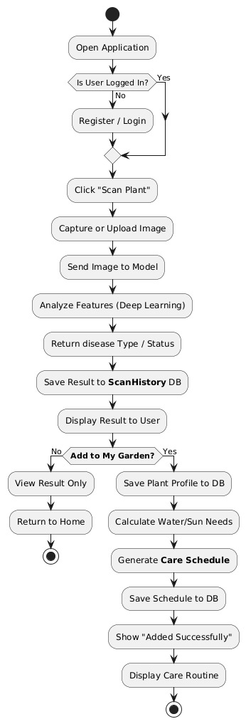
The inference workflow describes the complete process from image capture to diagnostic result and treatment recommendation:

3.2.2 Entity Relationship (ER) Diagram
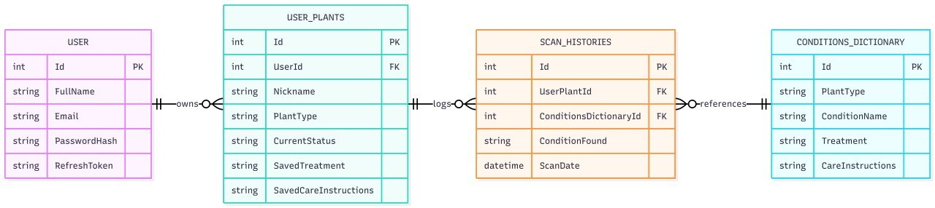
The database schema for the Microsoft SQL Server backend centers around five core entities: a User owns multiple User_Plants, and each plant logs its health journey in Scan_Histories. The Conditions_Dictionary acts as a global knowledge base that caches AI-generated narratives, optimizing database performance and ensuring data consistency across the platform.

3.2.3 Class Diagram
Core classes include User, UserPlant, ScanHistory, ConditionsDictionary, and PlantLookup, mirroring the data model defined in Entity Framework Core. Each entity class corresponds to a database table managed through the ApplicationDbContext.
The User class encapsulates authentication state with properties for email, BCrypt-hashed password, refresh token management, and role-based access control. The UserPlant class represents individual plants in a user's collection, maintaining references to the owner, scan history, and cached AI-generated care instructions. ScanHistory provides an immutable audit trail of all diagnostic events, while ConditionsDictionary serves as a global cache for AI-generated treatment content.
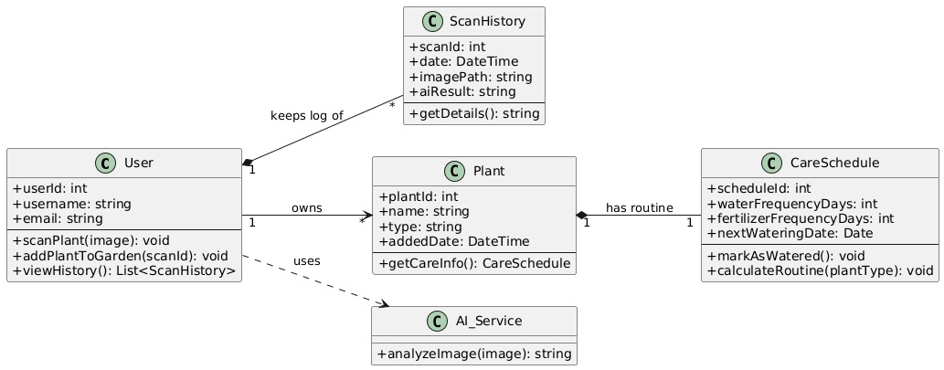

3.2.4 Sequence Diagram
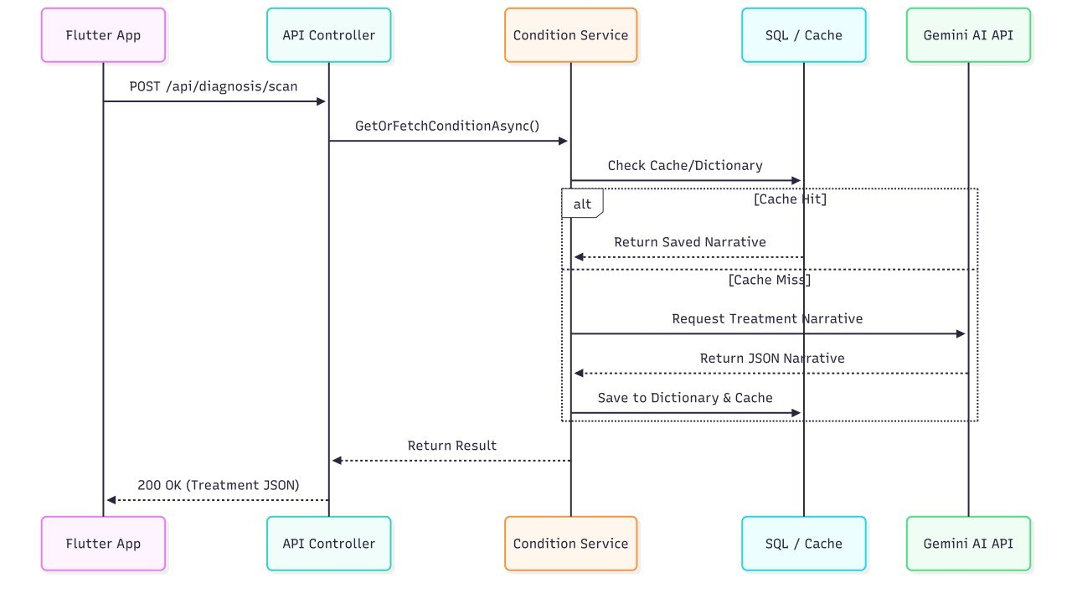
The sequence diagram illustrates the 'Scan & Diagnose' use case. The user initiates a scan through the Flutter application, which first executes TFLite inference on-device. If network connectivity exists, the application calls the backend API. The backend checks the ConditionsDictionary cache, conditionally queries the Gemini API on cache miss, and returns a structured JSON treatment plan to the mobile client for display.

3.2.5 Use Case Diagram
The use case diagram illustrates the primary interactions between users and the FloraAI system. Key use cases include capturing leaf photographs, receiving diagnostic results, viewing treatment recommendations, managing personal plant libraries, reviewing scan history, and synchronizing data across devices. Administrative use cases include system monitoring, cache management, and user analytics.
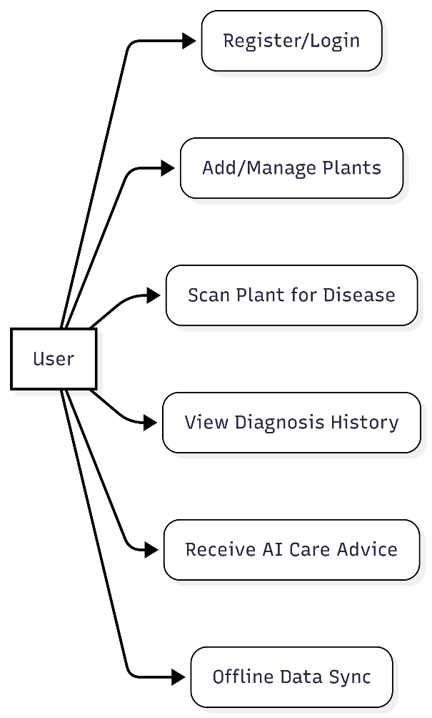
3.2.6 System Architecture Diagram
This diagram illustrates the Hybrid Architecture of the FloraAI ecosystem. It demonstrates the strict Separation of Concerns (SoC) between the client-side and server-side environments.
The Client-Side (Flutter): Showcases the "Edge Computing" paradigm where the MobileNetV2 TFLite model runs locally on the device for fast, offline disease detection, supported by an internal SQLite database for privacy-focused edge storage.
The Server-Side (ASP.NET Core): Highlights the N-Tier backend architecture. The API Controllers receive requests and delegate them to Business Logic Services.
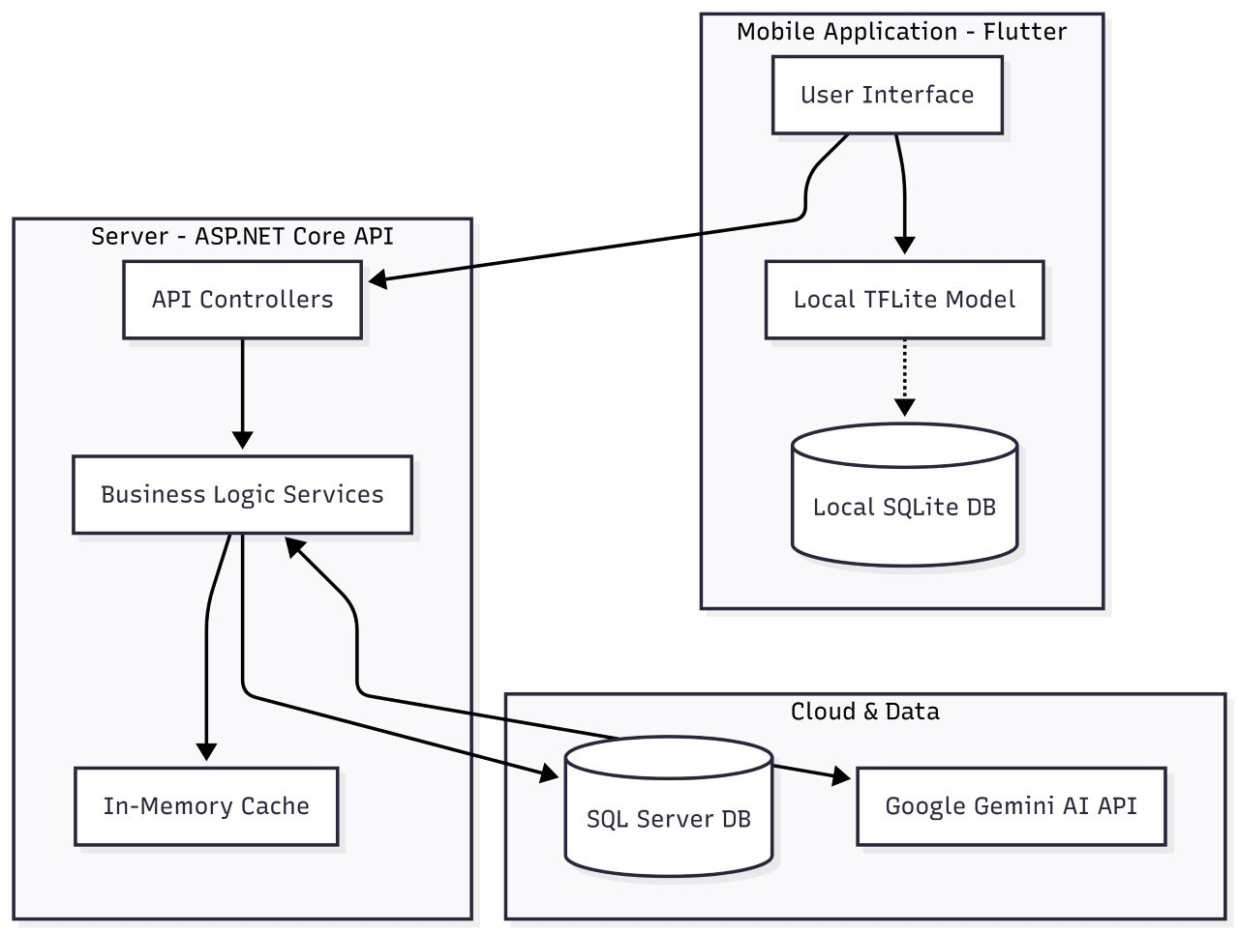
Cloud & Data: Demonstrates the strategic integration of an In-Memory Cache to intercept requests before they reach the SQL Server or the external Google Gemini AI API, ensuring minimal latency and reduced operational costs.

3.2.7 Data Flow Diagram (DFD Level 1)
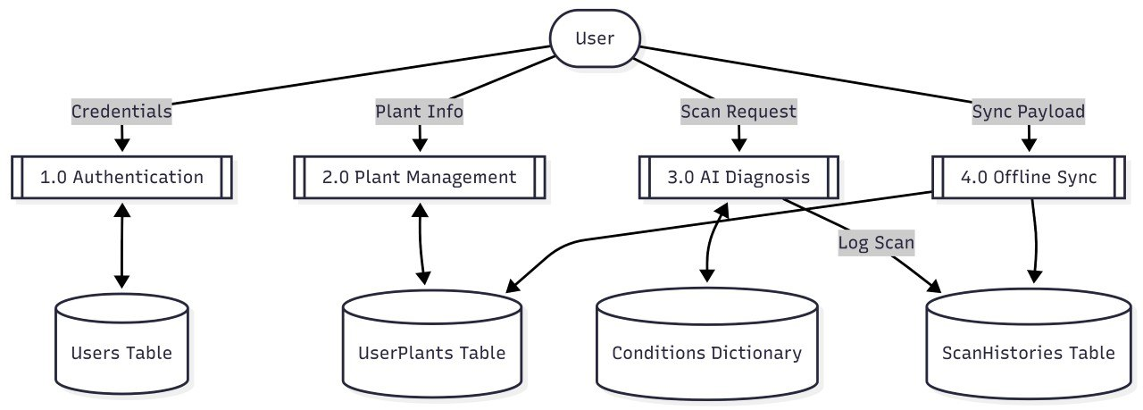
This Level 1 DFD visualizes the Logical Information Flow between system processes and data stores. It categorizes the backend into four major processes: Authentication, Plant Management, AI Diagnosis, and Data Sync. It explicitly shows how sensitive data (Credentials) and operational data (Scan Requests) are routed to their respective persistent storages.

3.3 Algorithms and Frameworks Used

3.3.1 Algorithms
1. Convolutional Neural Networks (CNN): The foundational deep learning architecture for image classification. CNNs automatically extract hierarchical visual features from leaf images, edges and colors in early layers, textures and patterns in middle layers, and complex pathogen signatures in deeper layers, without requiring manual feature engineering.
2. Transfer Learning: Rather than training from scratch, FloraAI leverages pre-trained weights from ImageNet. Early network layers, which learn general visual features, are frozen while deeper layers are fine-tuned for pathogen-specific classification. This approach significantly improves accuracy with limited training data.
3. Adam Optimizer: The adaptive moment estimation optimizer automatically adjusts learning rates per parameter during training, accelerating convergence toward optimal weights while minimizing cross-entropy loss.
4. Softmax Activation: The final layer applies Softmax normalization to convert raw network outputs into probability distributions across the five classification classes (Fungi, Bacteria, Virus, Pests, Healthy), enabling confidence-based decision making.

3.3.2 Frameworks and Tools
1. TensorFlow (v2.x) & Keras: The primary machine learning framework. Keras provides a high-level API for model construction and hyperparameter tuning, while TensorFlow's GPU acceleration significantly reduces training time for computationally intensive deep learning operations.
2. TensorFlow Lite: Model conversion and optimization framework that compresses trained networks for mobile deployment. TFLite enables efficient on-device inference through quantization, operator fusion, and memory optimization.
3. Flutter (Dart): Cross-platform mobile development framework managing the user interface, camera integration, image preprocessing, TFLite interpreter communication, and backend API connectivity.
4. ASP.NET Core (.NET 8): High-performance backend framework powering the RESTful API, user authentication, AI service orchestration, and data synchronization.
5. Microsoft SQL Server: Relational database management system storing user data, diagnostic logs, and cached AI-generated content via Entity Framework Core OR.
6. Google Gemini 2.5 Flash API: Cloud-based Large Language Model generating contextually aware, narrative treatment advice in Arabic with specialized prompt engineering.
7. Redis: Distributed caching layer providing high-speed token blacklisting and admin dashboard statistics computation.
8. Polly: Resilience library implementing Retry, Circuit Breaker, and Fallback patterns for external API communication fault tolerance.

3.4 Frontend Architecture & Edge AI Design

3.4.1 Cross-Platform Framework Selection
The selection of a client-side development framework carries significant long-term implications for maintainability, performance, and developer productivity. Flutter, developed and maintained by Google, was selected as the frontend foundation for FloraAI based on several analytically justifiable criteria. Unlike bridge-based architectures such as React Native, which route JavaScript execution through a platform-specific communication layer, Flutter compiles Dart code ahead-of-time (AOT) directly to native ARM machine code. This eliminates interpretive overhead and ensures frame-rendering performance comparable to natively developed iOS and Android applications. For FloraAI, this is critical: the image preprocessing pipeline—responsible for pixel-by-pixel tensor construction from 224×224 resized images—executes with minimal latency under AOT compilation. Furthermore, Flutter’s Skia (and Impeller) rendering engine bypasses native platform widget systems entirely, guaranteeing pixel-perfect visual consistency across Android and iOS without platform-specific workarounds. Dart’s strong typing and first-class asynchronous programming model (via Future and Stream abstractions) further enable the multi-stage diagnostic pipeline to be expressed linearly while keeping the UI thread responsive.

3.4.2 State Management Strategy
State management in Flutter requires careful architectural alignment between component complexity and management overhead. FloraAI employs a pragmatic, layered approach:
- Widget-Local State: Ephemeral UI states intrinsic to a single screen such as the isAnalyzing flag, selected image path, and diagnostic result strings are managed via Flutter’s built-in setState mechanism. This avoids unnecessary indirection for transient, non-persistent values.
- Cross-Screen Shared State: Data requiring persistence across navigation boundariesspecifically the myplants list and currentUserName is maintained as top-level global references. While this trades strict encapsulation for simplicity, it is pragmatically justified at FloraAI’s current scale and eliminates the need to thread complex objects through deep widget constructor chains.

- Reactive Global Preferences: Application-wide theme selection is managed via a ValueNotifier<String> wrapped in a ValueListenableBuilder at the root MaterialApp level. This ensures instantaneous propagation of theme changes across the entire widget tree without triggering full application reloads.
- Optimistic UI Locking: During inference execution, the isAnalyzing flag immediately disables the primary action button, replaces its label with a localized loading indicator, and renders a CircularProgressIndicator. This prevents duplicate inference requests while providing transparent system-state feedback.

3.4.3 Edge AI Paradigm & Offline-First Philosophy
FloraAI deliberately departs from conventional client–server inference models by embedding diagnostic intelligence directly within the mobile client. This architectural philosophy commonly termed Edge AI addresses four critical deployment constraints:
- Latency Minimization: Network round-trip times for cloud inference typically range from 50ms to several seconds. On-device execution via TensorFlow Lite reduces inference latency to tens of milliseconds, yielding immediate diagnostic feedback.
- Privacy Preservation: By processing leaf images exclusively on-device, FloraAI eliminates exposure of potentially sensitive contextual metadata (e.g., EXIF geolocation, background elements) to third-party servers, inherently satisfying stringent data protection principles without relying on cryptographic transmission alone.
- Offline Availability: Core diagnostic functionality remains fully operational in environments with intermittent or absent network connectivity, a critical requirement for horticultural use cases in rural or low-signal environments.
- Operational Cost Reduction: On-device inference replaces per-request cloud API billing with a one-time model training and optimization investment, ensuring sustainable scaling regardless of user volume.

3.4.4 User Experience & Progressive Disclosure
The FloraAI interface adheres to the principle of progressive disclosure, revealing complexity incrementally as the user advances through the diagnostic workflow. The primary journey is structured into six distinct phases:
- Contextual Preparation, where photography guidelines reduce diagnostic errors before capture.
- Image Acquisition, utilizing a modal bottom sheet for camera or gallery selection.
- Pre-Analysis Review, allowing image verification prior to inference.
- Inference in Progress, employing optimistic UI locking and animated loading indicators to maintain perceived responsiveness.
- Result Presentation, progressively rendering diagnostic and treatment cards only upon successful model output; and
- Record Persistence, enabling users to attach results to specific plant profiles via a DraggableScrollableSheet. Supplementary network-dependent features are presented as contextual enhancements rather than primary affordances, ensuring core functionality remains uninterrupted in offline environments.

Chapter 4

Implementation

4.1 Technologies, Tools, and Programming Languages
Programming Languages
- Python (v3.10+): Primary language for all AI and data science operations, including data preparation, model training, evaluation, and TensorFlow Lite conversion.
- Dart: Used with Flutter for cross-platform mobile application development targeting both Android and iOS.
- C#: Backend development language leveraging .NET 8 for secure, high-performance server-side operations.
Mobile Development & UI/UX Design
- Flutter: Cross-platform mobile framework enabling single-codebase deployment with native performance and responsive user interface. Unlike bridge-based architectures, Flutter compiles Dart ahead-of-time (AOT) directly to native ARM machine code, eliminating interpretive overhead and ensuring frame-rendering performance comparable to natively written applications.[22].
- Visily: UI/UX design and prototyping tool used for wireframe creation and interface polish before implementation.
Backend & API Development
- .NET 8 (ASP.NET Core): Powers the RESTful API, connecting the Flutter application with the database, handling user management, and ensuring secure, efficient data transmission.
- Entity Framework Core: Code-First ORM providing type-safe database access, automatic schema migration, and simplified data operations.
- Redis: Distributed cache for token blacklisting and high-performance admin dashboard statistics.
- Polly: Resilience library providing Retry, Circuit Breaker, and Fallback policies for external API calls.

Deep Learning Frameworks & Libraries
- TensorFlow & Keras: Core tools for building and training deep learning CNN models. Keras simplifies architecture prototyping while GPU acceleration reduces training time.
- TensorFlow Lite: Converts trained models into optimised .tflite files for efficient on-device mobile inference. FloraAI's TFLite integration uses two sequential interpreter instances rather than a single classifier. The first model (leaf_validator.tflite) acts as a gate, rejecting non-botanical inputs below a 0.80 confidence threshold before the disease classifier is invoked. This prevents spurious outputs for arbitrary non-leaf inputs and ensures diagnostic integrity [23].
- Pandas & NumPy: Data manipulation and numerical computation libraries for image path management, label encoding, and array operations.
- Matplotlib & Seaborn: Visualisation libraries for training curves, confusion matrices, and performance analysis charts.
- Scikit-learn: Machine learning utilities for dataset splitting, classification metrics, and model evaluation.
Development Tools & Environments
- Kaggle Notebooks: Primary cloud training environment providing free access to NVIDIA Tesla P100 GPUs for accelerated model training.
- Visual Studio Code: Main IDE for Flutter application development and debugging.
- Visual Studio / Rider: IDE for C# backend development with advanced debugging and refactoring capabilities.

4.2 Backend System Analysis & Architecture

4.2.1 Introduction to the Backend Ecosystem
The FloraAI backend serves as the computational brain and centralized data repository for the broader FloraAI mobile ecosystem. Built upon the robust foundation of C# and the cross-platform capabilities of ASP.NET Core (.NET 8), the backend handles complex diagnostic orchestrations, secure data persistence, and high-latency integrations with artificial intelligence models.
Unlike traditional monolithic applications, the FloraAI backend functions as a 'Hybrid AI Orchestrator,' seamlessly bridging the gap between lightweight on-device Edge computing (the Flutter client's MobileNetV2 model) and computationally intensive Cloud intelligence (Google's Gemini 2.5 Flash API). This duality necessitates an architecture that is inherently resilient, highly scalable, and strictly modular.
Functional requirements
define the explicit behaviors and operational capabilities the backend must possess:
1. Identity and Access Management: Secure user registration, authentication, and authorization utilizing JSON Web Tokens (JWT) with Refresh Token rotation workflow to prevent arbitrary session termination.
2. Diagnostic Orchestration: API endpoint receiving localized plant disease classifications and querying the Gemini AI LLM to generate narrative, disease-specific treatment protocols.
3. Personalized Plant Libraries: CRUD operations for users to manage digital libraries of their physical plants with chronological diagnostic scan history.
4. Offline-First Synchronization: Processing bulk data payloads from mobile clients during network unavailability with conflict resolution upon restoration.
5. Knowledge Base Caching: Autonomous capture and persistence of Gemini AI outputs into a centralized ConditionsDictionary serving as a global knowledge base.

Non-functional requirements
dictate the qualitative metrics and architectural constraints:
1. Latency and Performance: Given inherent LLM API latency (3-5 seconds per request), In-Memory Caching reduces response times for previously diagnosed conditions to under 50 milliseconds.
2. System Scalability: Architecture must handle concurrent HTTP requests without thread starvation through asynchronous programming (async/await) across all I/O bound operations.
3. Data Security: Sensitive user data, specifically passwords, must be securely hashed using BCrypt. All endpoints (excluding authentication) protected via Role-Based Access Control (RBAC).
4. Fault Tolerance: Backend must not cascade failures from third-party API outages. Transient fault handling (Retry and Circuit Breaker patterns via Polly library) required for external HTTP communications.

4.2.3 Architectural Pattern: The N-Tier / Layered Approach
To fulfill rigorous requirements and ensure long-term maintainability, the FloraAI backend implements the N-Tier (Layered) Architectural Pattern. This methodology organizes the application into isolated horizontal layers, each with distinct responsibility boundaries interacting solely with the layer immediately beneath.
Presentation Layer (Controllers): The singular entry point for all client requests. Implemented via ASP.NET Core Web API Controllers, this deliberately 'thin' layer intercepts HTTP requests, enforces endpoint security through [Authorize] attributes, validates incoming JSON payload structure via Data Annotations, delegates business logic execution to the Services Layer, and formats HTTP responses with standardized status codes.
Controller | Base Route | Function | Protection
AuthController | /api/auth | Registration, login, token refresh, logout | AuthLimit
DiagnosisController | /api/diagnosis | Plant condition diagnosis using AI hybrid workflow | DiagnosisLimit
ConditionsController | /api/conditions | Disease dictionary management | [Authorize]
UserPlantsController | /api/userplants | Personal plant library management | [Authorize]
ScanHistoryController | /api/scanhistory | View and manage scan history | [Authorize]
SyncController | /api/sync | Offline data synchronization to server | [Authorize]
PlantLookupController | /api/plantlookup | Plant discovery search index | Public
AdminController | /api/admin | Admin statistics dashboard | Admin Role

Business Logic Layer (Services): The computational heart encapsulating domain-specific rules, data transformations, and external API orchestrations. Every service abstracts behind a C# Interface enabling Dependency Injection and isolated unit testing through mock dependency injection.
Service | Interface | Responsibility
UserService | IUserService | Registration, authentication, BCrypt hashing, Refresh Token management
TokenService | ITokenService | JWT Access Token generation, random Refresh Token generation
TokenBlacklistService | ITokenBlacklistService | Immediate token revocation on logout via Redis cache
GeminiService | IGeminiService | Gemini 2.5 Flash API communication, prompt engineering, response handling
ConditionService | IConditionService | Disease dictionary management, intelligent caching, JSON extraction
DiagnosisService | IDiagnosisService | Diagnosis workflow coordination, scan history logging
UserPlantService | IUserPlantService | Personal plant library management with pagination support
SyncService | ISyncService | Processing offline-mode sync data from mobile client
AdminService | IAdminService | System statistics computation with Redis distributed caching

Data Access Layer (EF Core): Abstracts relational database complexity through Entity Framework Core as the Object-Relational Mapper (ORM). The ApplicationDbContext contains five DbSets representing the main database tables: Users, UserPlants, ScanHistories, ConditionsDictionary, and PlantLookups. Automatic retry on failure is configured with maximum 5 attempts and 30-second timeout, ensuring connection stability in shared hosting environments.

4.2.4 Justification for Separation of Concerns
The paramount justification for N-Tier architecture lies in Separation of Concerns (SoC). In unlayered monolithic applications, business rules, database queries, and HTTP routing become deeply intertwined, creating fragile codebases where minor schema modifications can inadvertently break API routing logic.
By enforcing SoC, the FloraAI backend achieves critical software engineering objectives:
- Testability: The Business Logic Layer, devoid of HTTP context and direct database connections, enables comprehensive validation through high-speed, isolated Unit Tests.
- Maintainability: Developers can refactor, optimize, or rewrite the Data Access Layer without modifying Business Logic Layer code.
- Team Velocity: Frontend developers rely on stable, contract-based API endpoints while backend engineers concurrently iterate on AI orchestration algorithms.

4.3 Data Dictionary & Database Design
The FloraAI backend utilizes a relational database management system orchestrated through Entity Framework Core using a Code-First approach. This methodology ensures direct synchronization between the database schema and C# domain models, providing robust type safety and version control via Migrations.

4.3.1 User Entity (Users Table)
The User entity serves as the foundational component for authentication and authorization, securely storing credentials and managing session state through JWT refresh tokens.
Field Name | Data Type | Constraints | Description & Justification
Id | int / INT | PK, Identity(1,1) | Unique surrogate primary key for the user record.
FullName | string / NVARCHAR(MAX) | Required, NOT NULL | User's complete name for personalized UI interactions.
Email | string / NVARCHAR(MAX) | Required, Unique, NOT NULL | Primary authentication identifier. Uniqueness prevents duplicate accounts.
PasswordHash | string / NVARCHAR(MAX) | Required, NOT NULL | BCrypt cryptographic hash preventing plaintext password exposure.
RefreshToken | string? / NVARCHAR(MAX) | Nullable | Cryptographic string for JWT Access Token renewal without re-authentication.
RefreshTokenExpiry | DateTime? / DATETIME2 | Nullable | Absolute expiration timestamp for RefreshToken theft mitigation.
Role | Enum / INT | Default: 0 (User) | RBAC level: User (0) or Admin (1).

4.3.2 UserPlant Entity (UserPlants Table)
Represents the virtual library of physical plants owned by a specific user, establishing a one-to-many relationship with the User entity.
Field Name | Data Type | Constraints | Description & Justification
Id | int / INT | PK, Identity(1,1) | Unique surrogate primary key.
UserId | int / INT | FK, Required, NOT NULL | Foreign key referencing User.Id. Establishes plant ownership.
Nickname | string / NVARCHAR(MAX) | Required, NOT NULL | Personalized name (e.g., 'Office Pothos').
PlantType | string / NVARCHAR(MAX) | Required, NOT NULL | Biological classification for AI diagnostic context.
CurrentStatus | string / NVARCHAR(MAX) | Required, NOT NULL | Overarching health status (e.g., 'Healthy', 'Sick').
SavedTreatment | string? / NVARCHAR(MAX) | Nullable | Cached AI-generated treatment protocol from last diagnosis.
SavedCareInstructions | string? / NVARCHAR(MAX) | Nullable | Cached preventative care advice relevant to plant history.
CreatedAt | DateTime / DATETIME2 | Default: UtcNow | UTC timestamp when plant was added to library.

4.3.3 ScanHistory Entity (ScanHistories Table)
Acts as an immutable ledger recording every diagnostic scan, enabling longitudinal health tracking over time.
Field Name | Data Type | Constraints | Description & Justification
Id | int / INT | PK, Identity(1,1) | Unique surrogate primary key.
UserPlantId | int / INT | FK, Required, NOT NULL | Links scan to specific physical plant.
ConditionsDictionaryId | int / INT | FK, Required, NOT NULL | Points to AI-generated diagnosis.
ConditionFound | string / NVARCHAR(MAX) | Required, NOT NULL | Localized disease category detected by Edge AI.
ScanDate | DateTime / DATETIME2 | Default: UtcNow | Exact UTC timestamp of diagnostic event.

4.3.4 ConditionsDictionary Entity
Critical architectural optimization serving as centralized, global knowledge base caching expensive Gemini LLM outputs. Previously queried disease/plant combinations retrieve narrative advice from this table, drastically reducing API latency and operational costs.
Field Name | Data Type | Constraints | Description & Justification
Id | int / INT | PK, Identity(1,1) | Unique surrogate primary key.
PlantType | string / NVARCHAR(MAX) | Required, NOT NULL | Species or category evaluated by LLM.
ConditionName | string / NVARCHAR(MAX) | Required, NOT NULL | Specific disease or condition. Composite unique constraint with PlantType.
Treatment | string? / NVARCHAR(MAX) | Nullable | Narrative curative protocol generated by Gemini AI.
CareInstructions | string? / NVARCHAR(MAX) | Nullable | Disease-specific preventative care advice.
LastUpdated | DateTime / DATETIME2 | Default: UtcNow | Cache invalidation timestamp.

4.3.5 PlantLookup Entity
Static, read-optimized index populating search and discovery features independently of user-specific data.
Field Name | Data Type | Constraints | Description & Justification
Id | int / INT | PK, Identity(1,1) | Unique surrogate primary key.
CommonName | string / NVARCHAR(MAX) | Required, NOT NULL | Standardized localized common name.
DefaultImage | string? / NVARCHAR(MAX) | Nullable | URI to default visual representation.

4.3.6 Entity Relationship Summary
Relationship | Type | Description
User -> UserPlant | One-to-Many (1:N) | Each user owns multiple plants.
UserPlant -> ScanHistory | One-to-Many (1:N) | Each plant has multiple scan records.
ConditionsDictionary -> ScanHistory | One-to-Many (1:N) | One diagnosis referenced by many scans.
PlantLookup | Independent | Read-only discovery index, no FK relationships.

4.4 API Design & Endpoints Documentation

4.4.1 RESTful API Principles
The FloraAI backend strictly adheres to Representational State Transfer (REST) principles, ensuring stateless, client-server communication that is highly scalable and easily consumable by the Flutter mobile application.
- Statelessness: Every HTTP request contains all necessary context (JWT in Authorization header), eliminating server-side session management.
- Resource-Based Routing: Endpoints structured around core domain entities utilizing standard HTTP verbs (GET, POST, PUT, DELETE).
- Standardized Responses: All list-based endpoints enforce generic PagedResponse<T> wrapper for pagination consistency and mobile bandwidth optimization.

4.4.2 Authentication & Authorization Endpoints (/api/auth)
This module governs identity management, ensuring secure access via JSON Web Tokens (JWT).
User Registration (POST /api/auth/register):
- Creates new account with full name, email, and password validation.
- Returns 201 Created with JWT Access Token, Refresh Token, and expiration timestamp on success.
- Returns 400 Bad Request for validation failures (weak password format).
- Returns 409 Conflict for duplicate email addresses.
User Authentication / Login (POST /api/auth/login):
- Returns 200 OK with Access and Refresh Token pair on valid credentials.
- Returns 401 Unauthorized for invalid email or password.
Token Refresh (POST /api/auth/refresh):
- Accepts expired Access Token plus valid Refresh Token.
- Implements Refresh Token Rotation, invalidating old token and issuing fresh pair.
- Returns 401 Unauthorized for expired or invalid Refresh Token.

4.4.3 User Plant Library Endpoints (/api/userplants)
All endpoints require valid JWT Bearer token.
Retrieve User's Plant Library (GET /api/userplants/user/{userId}?pageNumber=1&pageSize=10):
- Returns paginated PagedResponse<UserPlant> with metadata (totalRecords, hasNextPage).
- Returns 403 Forbidden when attempting to access another user's library.
Add Plant to Library (POST /api/userplants/save):
- Returns 201 Created on successful persistence.
- Returns 400 Bad Request for missing mandatory fields.

4.4.4 AI Diagnosis & Integration Endpoints (/api/diagnosis)
The critical bridge between mobile Edge AI (TFLite model) and Cloud LLM (Gemini 2.5 Flash).
Execute Plant Scan (POST /api/diagnosis/scan):
- Receives localized disease classification from mobile app.
- Queries caching layer or Gemini API for treatment and care protocol generation.
- Returns 200 OK with Arabic treatment and care instructions on success.
- Returns 429 Too Many Requests when rate limit exceeded.
- Returns 500 Internal Server Error on Gemini API upstream failure, triggering Polly fallback policies.

4.4.5 Offline-First Synchronization Endpoints (/api/sync)
The Flutter client utilizes SQLite for local storage during network unavailability. This module synchronizes local data with central SQL Server upon restoration.
Bulk Data Synchronization (POST /api/sync/offline-data):
- Accepts bulk payload of locally created diagnostic scans and plant modifications.
- Integrates into central database with conflict resolution.
- Returns 200 OK with counts of plants and scans synchronized.

4.4.6 Admin Statistics Endpoints (/api/admin)
Get Admin Statistics (GET /api/admin/stats):
- Protected by [Authorize(Roles = 'Admin')] attribute.
- Returns system-wide statistics: total users, total scans, most diagnosed conditions, cache hit rates.
- Returns 403 Forbidden for non-admin users.

4.5 Security, Performance & Implementation Details

4.5.1 Authentication Workflow (JSON Web Tokens)
Security implements stateless authentication via JSON Web Tokens (JWT), eliminating server-side session storage and enabling horizontal API scaling without session consistency bottlenecks.
Token Generation and Payload Claims: Upon successful credential validation using BCrypt hashing, the TokenService generates an Access Token signed with HMAC-SHA256. The token payload embeds critical metadata: NameIdentifier (user ID), Email, and Role claims enabling strict RBAC enforcement via [Authorize(Roles = 'Admin')] attributes.
Refresh Token Rotation and Blacklisting: Access Tokens are short-lived (15 minutes) to minimize theft attack windows. Long-lived cryptographically secure Refresh Tokens enable seamless session renewal. Upon Access Token expiration, the client submits both tokens; the system validates both, invalidates the old Refresh Token, and issues a fresh pair (Refresh Token Rotation). On explicit logout, the Token Blacklisting Mechanism stores the Access Token's JTI in Redis cache until expiration, immediately revoking access without database I/O.

4.5.2 Performance Optimization Strategy
In-Memory and Distributed Caching: The primary latency bottleneck involves external HTTP calls to the Gemini LLM (averaging 3-5 seconds). The ConditionService implements a sophisticated two-tier caching strategy:
1. Persistent Cache (Database): First queries ConditionsDictionary table for previously generated advice.
2. Cache Hit: Returns cached content immediately.
3. Cache Miss: Invokes Gemini API, persists response to ConditionsDictionary, and returns result.
4. Redis Distributed Cache: Frequently accessed admin statistics utilize Redis for sub-millisecond retrieval.
Database Query Optimization: EF Core interactions systematically prevent the N+1 Query Problem through eager loading (Include() operator) for related entities. Read-only queries enforce .AsNoTracking() to bypass the Change Tracker, significantly reducing memory allocation.

4.5.3 Artificial Intelligence Integration (Gemini API)
Prompt Engineering and Persona Definition: The system utilizes advanced prompt engineering defining a specific AI persona ('Dr. Flora'). The prompt strictly enforces structured JSON output, bypassing standard Markdown formatting and ensuring predictable schema elements (Treatment and CareAdvice separation) for granular UI rendering.
Resilience and Fault Tolerance (Polly Policies): The GeminiService HttpClient integrates Polly resilience patterns:
Polly Policy | Trigger Condition | Behavior
Retry (Exponential Backoff) | HTTP 503, network timeout | Retries 3 times: 2s, 4s, 8s wait
Circuit Breaker | 5+ consecutive failures within 30s | Opens circuit for 60 seconds
Fallback | All retries exhausted / circuit open | Returns hardcoded generic care advice
The Fallback Policy implements graceful degradation. If LLM integration fails completely, the system returns hardcoded universally applicable plant care instructions, ensuring the mobile client always receives actionable data rather than unhandled exceptions.

4.6 Key Components/Modules of the System

Module 1: The Data Processing Pipeline
This module prepares raw data for AI model consumption:
- Data Ingestion: Loads images from pathogen-dataset folders organized by category (Fungi, Bacteria, Virus, Pests, Healthy).
- Preprocessing: Resizes images to 224x224 pixels and normalizes pixel values (scaling to [-1, 1] for MobileNetV2 compatibility).
- Augmentation Engine: Boosts training diversity through random transformations, rotation, zoom, flip, brightness adjustment, enabling better generalization across real-world conditions.

Module 2: The Universal Pathogen Classifier (AI Core)
The system's classification engine categorizing leaf health into five pathogen classes:
- Architecture Selection: Three model architectures evaluated: MobileNetV2 (lightweight, mobile-optimized), EfficientNetB0 (compound scaling efficiency), and ResNet50 (deep feature extraction with residual connections).
- Transfer Learning Head: Custom classification block atop pre-trained models: GlobalAveragePooling2D, Dropout (overfitting prevention), and final Dense layer with Softmax activation.
- Training Monitor: Callbacks including ModelCheckpoint (best epoch preservation), EarlyStopping (overfitting prevention), and ReduceLROnPlateau (adaptive learning rate adjustment).

Module 3: The Mobile Integration Layer
Links the trained model to the Flutter mobile application:
- TFLite Interpreter: Executes the .tflite model directly on the user's smartphone without network connectivity.
- Inference Logic: Captures camera image, preprocesses to model input dimensions, executes inference, and outputs clear diagnosis with confidence score (e.g., 'Fungal Infection - 95% Confidence').

Module 4: The Backend AI Orchestration Layer
Coordinates between mobile Edge AI and Cloud Gemini LLM:
- Diagnosis Endpoint: /api/diagnosis/scan receives classification data and orchestrates caching/LLM workflow.
- Cache-First Strategy: Checks ConditionsDictionary before calling expensive Gemini API. Cache hits return responses under 50ms.
- Gemini Integration: Constructs 'Dr. Flora' persona prompt and calls Gemini 2.5 Flash API for narrative Arabic treatment plans on cache miss.
Module 5: State Management & UI/UX Architecture
governs how application state is managed across the widget tree and how the user is guided through the diagnostic workflow. FloraAI adopts a layered state management approach that matches the complexity of each component's state requirements to the appropriate mechanism, rather than imposing a single paradigm uniformly across the application.
- Widget-Local State via setState: Manages ephemeral, single-screen data (e.g., isAnalyzing, selected images) to eliminate unnecessary indirection and boilerplate.
- Global Mutable State for Cross-Screen Shared Data: Uses top-level global variables for persistent data (e.g., myplants list, username) to avoid threading data through widget constructors.
- ValueNotifier for Theme Reactivity: Employs a ValueNotifier<String> and ValueListenableBuilder at the root for efficient, immediate app-wide theme propagation.
- Optimistic UI Locking During Inference: Instantly sets isAnalyzing to true, triggering a loading indicator and disabling the button to prevent duplicate submissions.

Module 6: Edge AI Justification & Technical Deep-Dive
Provides the theoretical justification for FloraAI's on-device strategy and MobileNetV2's computational efficiency.
- The Edge Computing Paradigm: Processes data at the source rather than centralized clouds, ensuring reliability in disconnected environments.
- Latency Minimization: Cuts response times from network round-trips to milliseconds via local TFLite inference on mobile NPUs/GPUs.
- Privacy Preservation: Eliminates cloud metadata exposure by processing images strictly on-device.
- Offline Availability: Functions fully as a diagnostic tool without internet connectivity.
- Reduced Operational Cost: Replaces recurring API billing with a one-time model optimization investment.

4.7 Challenges Faced and How They Were Resolved
Challenge | Description | Resolution Strategy
Model Overfitting | High training accuracy but poor validation accuracy indicating memorization rather than learning. | Implemented aggressive Data Augmentation and Dropout layers. Introduced EarlyStopping to halt training when validation loss ceased improving.
Domain Shift | Model performed well on dataset images but failed on real-world photos. | Identified lack of diversity in training data. Expanded dataset strategy and implemented robust preprocessing to standardize inputs.
Ambiguous Classes | Difficulty differentiating visually similar pathogens (e.g., bacterial vs. fungal spots). | Implemented Fine-Tuning, unfreezing top layers to learn more specific, subtle pathogen features.
Gemini API Null Responses | APIs vulnerable to malformed or empty data from Gemini during edge cases. | Implemented strict Fallback Logic ensuring default safety data is always returned during AI outages.
Offline Category Conflicts | Handling cases where mobile client submitted empty or erroneous category data. | Implemented server-side validation rules ensuring resilience against malformed inputs.
Spurious Disease Diagnoses from Non-Leaf Images | Non-botanical uploads (faces, objects) triggered confident but meaningless pathogen labels, undermining user trust. | Implemented a two-stage TFLite pipeline using a leaf_validator.tflite model to filter out non-plant images before disease classification.
UI Thread Freezing During Tensor Preprocessing | Synchronous, CPU-bound image preprocessing (decoding, resizing, normalization) caused UI freezes and dropped frames on low-end devices. | Offloaded the inference pipeline to an async Dart function to isolate it from the UI render thread, paired with optimistic UI locking.

4.8 Frontend & On-Device AI Implementation Details

4.8.1 TensorFlow Lite Integration & Inference Pipeline
TensorFlow Lite (TFLite) serves as FloraAI's production inference engine, integrated directly into the Flutter application through the tflite_flutter Dart package. The overall architecture is structured across three distinct and interdependent layers that work in concert to deliver efficient, reliable on-device inference. At the lowest level, the underlying C++ TFLite runtime is responsible for executing the raw computational graph, handling all tensor operations, memory allocation, and hardware delegation at the native binary level. Sitting above this, Dart FFI (Foreign Function Interface) bindings expose the native C++ library to the Dart application layer, enabling type-safe cross-language interoperability without sacrificing performance. At the highest level, the PlantInferenceService class encapsulates all model management logic, serving as the single authoritative abstraction through which the rest of the application interacts with inference capabilities.
Two separate Interpreter instances are initialized at the point of page entry one dedicated to leaf_validator.tflite and one dedicated to disease_classifier.tflite. This design deliberately employs an eager loading strategy, meaning both interpreters are fully initialized and warmed up before the user initiates any scan interaction. The rationale behind this decision is to amortize the initialization cost across the page lifecycle rather than incurring it at the moment of first inference. This prevents cold-start latency from degrading the user experience at the most critical interaction point, ensuring that when a user submits an image for analysis, the inference pipeline is already primed and ready to execute without delay.
Inference Pipeline Three Deterministic Stages
The complete inference pipeline is structured as a sequential, three-stage process. Each stage has clearly defined inputs and outputs, and stages are executed in strict order to ensure correctness and safety of the classification output.

Stage 1: Image Decoding & Preprocessing
The pipeline begins with the raw image bytes captured from the device camera or selected from the image library. These raw bytes are first decoded from their compressed representation and then resized to a fixed spatial resolution of 224×224 pixels using bicubic interpolation. Bicubic interpolation is selected over simpler methods such as nearest-neighbor or bilinear interpolation because it considers a 4×4 neighborhood of surrounding pixels when computing each output value, producing smoother, higher-quality downsampled images that better preserve fine structural details such as leaf venation patterns and lesion textures.
Following resizing, pixel intensity values are normalized from their original integer range of [0, 255] to a floating-point range of [-1.0, 1.0] using the transformation formula:
$$\text{normalized}=\left(\frac{\text{pixel}}{127.5}\right)-1.0$$
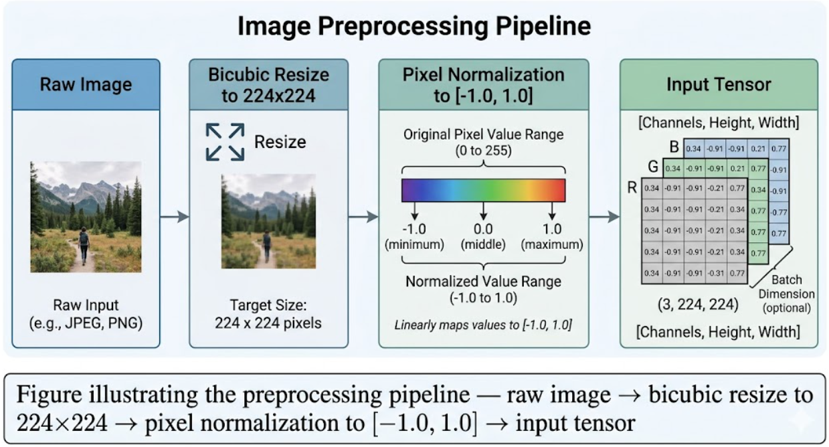
This specific normalization is not arbitrary it is chosen to precisely align with the preprocessing distribution applied during MobileNetV2's original ImageNet training. The pretrained feature representations encoded within MobileNetV2's weights were learned under this exact input distribution. Any deviation from this normalization scheme would introduce a distributional shift between training-time and inference-time inputs, causing the model's internal feature detectors to receive inputs outside the expected statistical range, which would severely degrade classification accuracy and reliability.

Stage 2: Leaf Validation
Once the input tensor has been constructed and normalized, it is forwarded to the leaf validator model as the first classification checkpoint. The validator model processes the tensor and produces a two-element probability vector corresponding to the classes {non-leaf, leaf}. These two probability values sum to 1.0 and represent the model's posterior confidence in each class assignment.
A confidence threshold of 0.80 is enforced on the leaf class probability. This threshold was selected to balance two competing risks: setting it too low risks allowing non-botanical inputs (e.g., photographs of hands, soil, or backgrounds) to pass through to the disease classifier, where they would generate spurious and potentially misleading outputs; setting it too high risks unnecessarily rejecting valid leaf images captured under challenging but legitimate conditions such as low ambient light or partial occlusion.
When an input image fails to meet the 0.80 leaf confidence threshold, the inference pipeline is immediately halted and the image is rejected at this stage. The user is presented with a clear, actionable prompt instructing them to recapture the image, ideally with better framing or lighting. This gate prevents the disease classifier from ever receiving non-botanical inputs, preserving the integrity and trustworthiness of the diagnostic output.
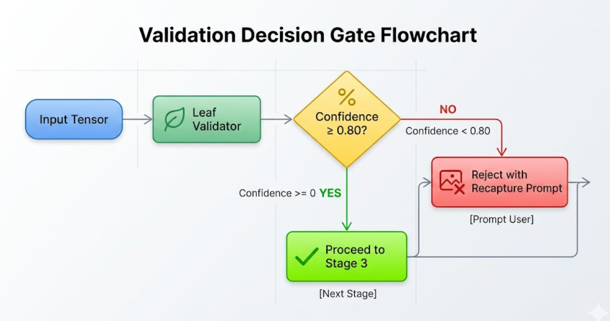

Stage 3: Disease Classification
Inputs that successfully pass the leaf validation gate are forwarded to the disease classifier model. The classifier processes the validated tensor and produces a five-element probability vector corresponding to the disease categories {healthy, fungi, bacteria, virus, pests}. Each element in the vector represents the model's posterior probability that the submitted leaf image belongs to that respective class.
The predicted class is determined by applying an argmax operation over the probability vector identifying the index position with the highest probability value and mapping it to its corresponding class label. The raw confidence score associated with the predicted class, expressed as a floating-point percentage, is extracted and formatted for display within the application's user interface, providing the user with both an actionable diagnosis and a transparent indication of the model's certainty level.

4.8.2 MobileNetV2 Architecture: Mathematical & Academic Justification
The selection of MobileNetV2 as the backbone architecture for FloraAI's classification models is not incidental it is grounded in a substantial body of academic research focused on efficient deep neural network design specifically for resource-constrained mobile and edge computing environments. Understanding why MobileNetV2 was chosen requires first appreciating the limitations of traditional high-accuracy convolutional neural networks when deployed outside server-side infrastructure.
Limitations of Traditional CNN Architectures for Mobile Deployment
Architectures that have historically achieved strong benchmark performance such as ResNet-50 and VGG-16 are designed primarily for accuracy maximization under the assumption of abundant computational resources. ResNet-50 carries approximately 25 million trainable parameters and requires roughly 4 billion floating-point operations (FLOPs) per single inference pass. VGG-16 is even more demanding, with approximately 138 million parameters and upward of 15 billion FLOPs per inference. On mobile devices with constrained CPU performance, limited RAM, absence of dedicated GPU compute, and battery capacity considerations, these architectures are fundamentally impractical. Inference times measured in seconds per image and memory footprints that compete with the device's entire application heap make them unsuitable for FloraAI's target deployment scenario.

Depthwise Separable Convolutions: Mathematical Foundation
MobileNetV2 addresses this computational burden through the principled application of depthwise separable convolutions, a factorization technique that decomposes a standard convolution operation into two separate, sequentially applied layers.
A standard convolution with a k×k kernel applied to an input with N input channels and M output channels produces an output where every output channel is a learned weighted combination of all input channels simultaneously. The computational cost of this operation, expressed in multiply-accumulate operations (MACs), scales as:
$${\text{Cost}}_{\text{standard}}=k×k×N×M×H×W$$
where H and W represent the spatial dimensions of the feature map.
Depthwise separable convolutions replace this monolithic operation with two distinct steps:
- Depthwise Convolution: A single k×k filter is applied independently to each individual input channel, producing one output feature map per input channel. This layer captures spatial patterns (edges, textures, shapes) within each channel independently, without mixing information across channels. Its computational cost is:
$${\text{Cost}}_{\text{depthwise}}=k×k×N×H×W$$
- Pointwise Convolution: A 1×1 convolution is then applied across all channels simultaneously, performing linear cross-channel mixing to produce the desired M output channels. This layer captures inter-channel relationships without spatial filtering. Its cost is:
$${\text{Cost}}_{\text{pointwise}}=N×M×H×W$$
The total cost ratio of depthwise separable versus standard convolution is therefore:
$$\frac{{\text{Cost}}_{\text{DS}}}{{\text{Cost}}_{\text{standard}}}=\frac{1}{M}+\frac{1}{k^{2}}$$

For a standard 3×3 kernel the most commonly used kernel size in modern CNN architectures this factorization yields a computational reduction factor of approximately 8 to 9 times, while academic benchmarks consistently report only a 1–3% accuracy trade-off on standard classification tasks. This represents an exceptionally favorable efficiency-accuracy trade-off for mobile deployment scenarios.
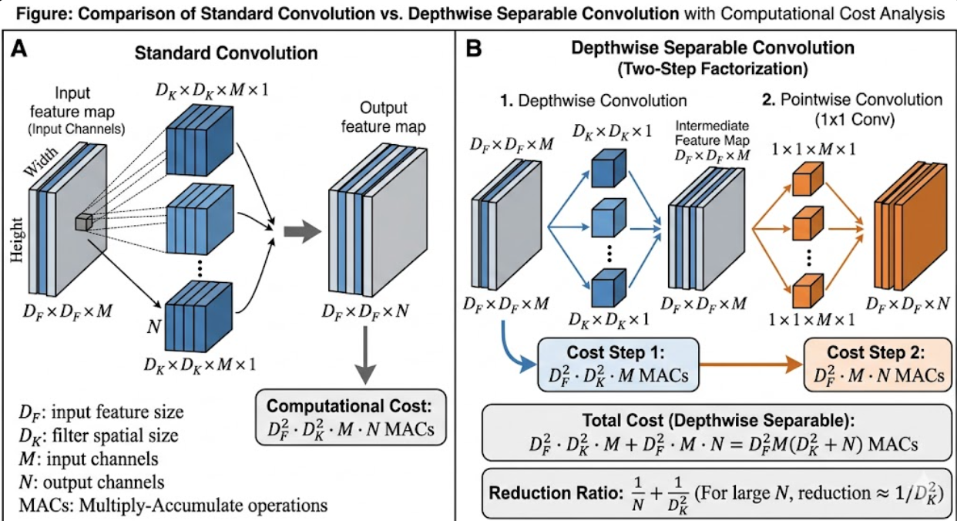
Inverted Residual Blocks & Linear Bottleneck Layers
MobileNetV2 further refines the depthwise separable convolution foundation through two architectural innovations: inverted residual blocks and linear bottleneck layers. Together, these innovations address a subtle but critical limitation of applying depthwise separable convolutions naively.
In ResNet-style architectures, residual connections link wide, high-dimensional feature representations and pass through narrow intermediate bottlenecks the information flows wide → narrow → wide, with skip connections spanning the wider layers. MobileNetV2 inverts this structure: the residual skip connections are placed between the narrow bottleneck layers, while the intermediate depthwise convolution operates in an expanded, high-dimensional intermediate space created by a preceding expansion convolution. The information flows narrow → wide → narrow, with the depthwise filtering occurring in the expanded space where it has access to richer representational capacity.

The linear bottleneck specifically, the deliberate use of a linear activation function (identity, no nonlinearity) in the final compression layer of each block addresses the problem of ReLU-induced information collapse in low-dimensional representations. When a ReLU activation is applied to a low-dimensional tensor, it sets all negative values to zero. In high-dimensional spaces, the manifold of useful information typically occupies only a small subspace, and some information survives the zeroing operation. In low-dimensional compressed
representations, however, this zeroing can irreversibly destroy information that cannot be recovered in subsequent layers. By using a linear activation at the compression step, MobileNetV2 preserves the full information content of the bottleneck representation, which is then passed through the residual skip connection.
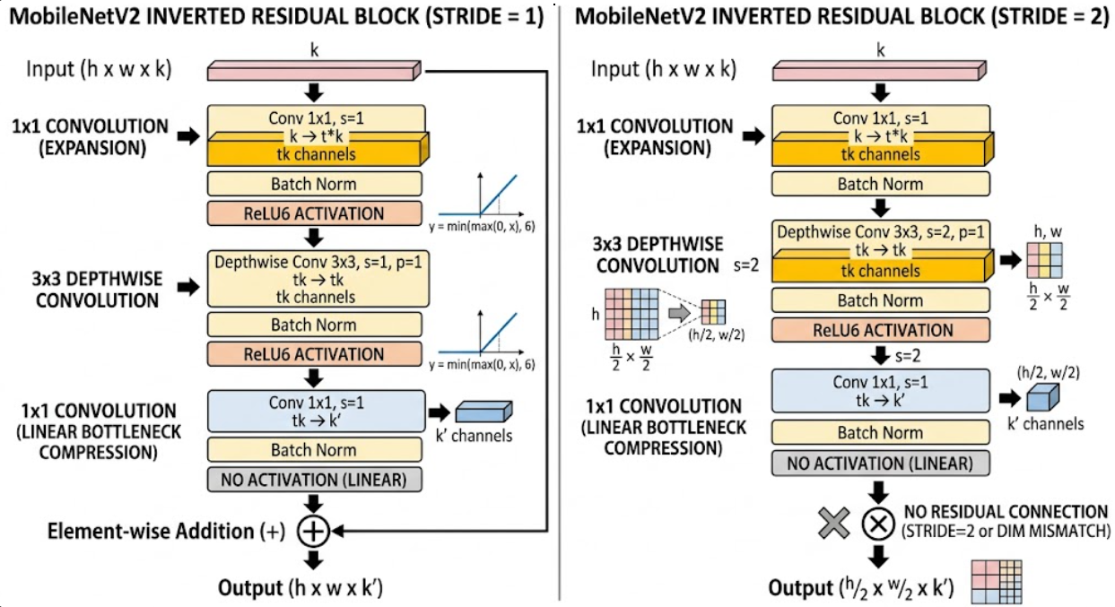

Quantitative Efficiency Summary
In aggregate, MobileNetV2 achieves its classification capability with only 3.4 million trainable parameters and approximately 300 million multiply-accumulate operations per inference pass representing a 14-fold reduction in computational cost compared to ResNet-50, while retaining the high-quality, transferable feature representations learned from ImageNet pretraining. These representations encode generalizable low- and mid-level visual features, including edges, surface textures, and compositional shape structures, that transfer effectively to the domain-specific task of plant disease classification without requiring full end-to-end retraining from random initialisation.
Beyond the architectural efficiency gains achieved through the network design itself, TFLite's 8-bit integer quantization pipeline is applied post-training to further reduce the model storage footprint by approximately 4 times converting 32-bit floating-point weight representations to compact 8-bit integer values with negligible accuracy degradation under standard post-training quantization benchmarks. The combined effect of MobileNetV2's architectural efficiency and TFLite quantization ensures that both model files can be embedded directly within FloraAI's application asset bundle, loaded entirely into device RAM during inference, and executed within latency budgets appropriate for interactive mobile use without requiring network connectivity or remote computation.
Metric | MobileNetV2 (1.0 width) | ResNet-50 | VGG-16
Parameter Count (Millions) | ~3.4 M | ~25.6 M | ~138 M
MACs per Inference (GMACs) | ~0.3 G | ~3.9 G | ~15.5 G
Model Size (FP32, MB) | ~14 - 16 MB | ~98 - 103 MB | ~528 - 550 MB
Model Size (INT8 quantized, MB) | ~3.5 - 4 MB | ~25 - 26 MB | ~138 MB
Approximate Top-1 ImageNet Accuracy | ~71.8% - 73.0% | ~76.0% - 78.5% | ~71.3% - 74.4%

4.8.3 Offline-First Data Storage & Filesystem Strategy
FloraAI implements a carefully designed hybrid offline-first storage model that combines structured relational indexing for metadata and logical relationships with direct filesystem management for binary image assets. This separation of concerns is a deliberate architectural decision that reflects well-established principles in mobile data management, and each component of the hybrid model serves a specific purpose that the other could not fulfill as efficiently.
Relational Data Model
The logical structure governing plant profiles and diagnostic histories is designed to conform to a normalized relational schema. This schema is organized around two primary tables:
- The plants table stores all metadata associated with a user's registered plants, including a unique identifier, a user-assigned display name, and care parameters such as watering frequency, light requirements, and species classification.
- The health_records table stores the results of individual diagnostic scans, including the per-scan disease classification result, the timestamp at which the scan was performed, references to relevant treatment recommendations, and a foreign key linking each record back to the corresponding entry in the plants table. This relational link allows the application to efficiently reconstruct a complete chronological health history for any given plant by performing a simple indexed lookup.
In the current single-session implementation, this relational structure is maintained entirely in-memory using Dart lists and class instances. This approach is appropriate for the current development stage because it provides rapid access and mutation without the overhead of disk I/O or query parsing, enabling fast iteration during development. The in-memory model accurately reflects the logical structure of the relational schema and is designed for straightforward migration. Production deployment will persist this state to disk using the sqflite package a Flutter-native SQLite binding which will guarantee full data survival across application restarts, device reboots, and application updates, without requiring changes to the overlying application logic.
Binary Image Asset Storage Strategy
Binary image assets the photographs captured during each diagnostic scan follow an entirely distinct storage strategy from the structured metadata. Rather than storing image data as Binary Large Objects (BLOBs) embedded directly within the SQLite database, FloraAI stores all images as discrete files within the device's application-specific internal directory and records only a lightweight filesystem path string as a column within the relational index.
This design decision was made deliberately and is justified by three concrete, independently significant advantages:
Bandwidth Conservation
Because all image data resides entirely on the local device filesystem, images never traverse any network connection at any point during their capture, storage, or retrieval. Historical scan images can be displayed instantly from the local filesystem without incurring any cellular data consumption, without depending on network availability, and without experiencing latency from remote server round-trips. This is particularly significant for FloraAI's target users, who may operate in rural or agricultural environments with limited or unreliable network connectivity.
Privacy Enforcement Through Application Sandboxing
Images stored within the application's sandboxed internal directory are subject to the operating system's application isolation guarantees on both Android and iOS. No other installed application can access files within FloraAI's private internal directory without explicit user-granted permissions or device-level compromise. This means that sensitive images of a user's plants and their associated health data are protected from third-party application access purely by the operating system's filesystem access control mechanisms, without requiring FloraAI to implement additional encryption layers, key management infrastructure, or remote access controls. The privacy guarantee is structural rather than operational.
Rendering Optimization via Native Decoding Pipelines
When images are retrieved for display within the application, Flutter's Image.file widget is used to load and render them directly from their filesystem path. This widget delegates the actual image decoding work to the platform-native image decoding pipeline leveraging hardware-accelerated decoders built into the Android and iOS operating systems ensuring that image previews are rendered as rapidly as possible without requiring any network fallback logic, custom decoding implementations, or intermediate data transformations. The result is instantaneous image preview rendering that feels native and responsive, even when displaying images from large historical scan libraries.

Chapter 5

Testing & Evaluation

5.1 Testing Strategies
The FloraAI testing strategy rigorously validates three primary objectives: Reliability, ensuring consistent operational behavior under varied conditions; Scalability, guaranteeing efficient handling of concurrent user requests; and Accuracy, verifying that Gemini AI integrations yield correct, contextually appropriate horticultural advice.
The testing methodology follows the Testing Pyramid approach: the foundation consists of extensive high-speed Unit Tests targeting isolated business logic; the middle tier comprises Integration Tests evaluating component interactions (API, EF Core, external APIs); the apex consists of end-to-end and Functional API Tests executing complete system workflows.

Unit Testing
Unit testing forms the bedrock of FloraAI quality assurance. Implemented using xUnit as the primary .NET testing framework with Moq library for mock dependency construction (database contexts, HTTP clients), ensuring true business logic isolation.
Core services, notably DiagnosisService and ConditionService, underwent rigorous testing to verify caching logic, AI fallback mechanisms, and diagnostic formatting operate flawlessly without requiring active database or network connections.
Test ID | Component | Scenario Description | Expected Outcome
UT-01 | GeminiService | Validating well-formed JSON response from Gemini API | Successfully parses and maps JSON to expected DTO
UT-02 | GeminiService | Handling malformed or unexpected responses (text instead of JSON) | Gracefully catches exception, logs error, returns fallback
UT-03 | TokenService | Requesting JWT generation for authenticated user with valid credentials | Valid JWT returned with correct Subject, Role, and Expiration claims
UT-04 | TokenService | Validating expired Refresh Token during token renewal | UnauthorizedAccessException thrown, halting issuance
UT-05 | ConditionService | Querying plant condition existing in local cache | Returns cached entity immediately without invoking Gemini API

Integration Testing
Integration testing validated seamless communication between architectural layers and external dependencies. Critical aspects included API interaction with SQL Server via EF Core using In-Memory Database providers for testing persistence layer operations, complex LINQ queries, referential integrity constraints, and database migrations.
Gemini AI service integration was tested using controlled environments validating actual network handshakes, API rate limit handling, and proper enforcement of JSON response structure dictated by prompt engineering constraints.

API & Functional Testing
Functional testing validated the system from the Flutter client perspective. Swagger UI enabled rapid manual endpoint verification during development, while automated API testing collections ensured endpoint stability across releases.
Test ID | Module | Scenario | Expected Result | Status
FT-01 | Auth | POST /api/auth/login with valid credentials | 200 OK + Tokens | Pass
FT-02 | Auth | POST /api/auth/login with invalid password | 401 Unauthorized | Pass
FT-03 | Diagnosis | POST /api/diagnosis/scan for new disease | 200 OK + AI treatment | Pass
FT-04 | UserPlants | GET /api/userplants/user/{id} without Auth Header | 401 Unauthorized | Pass
FT-05 | Sync | POST /api/sync/offline-data with bulk payload | 200 OK + Synced data | Pass
FT-06 | Admin | GET /api/admin/stats by non-admin user | 403 Forbidden | Pass

5.2 Performance Evaluation & Metrics

Deep Learning Model Performance
The core system relies on accurate plant disease identification. Standard classification metrics, Accuracy and Loss, evaluated three architectures: ResNet-50, MobileNetV2, and EfficientNet-B0.
Model Architecture | Hyperparameters | Training Acc. | Validation Acc. | Loss
ResNet-50 | Epochs: 15, BS: 16, LR: 0.001 | 98.7% | 98.6% | 0.04
EfficientNet-B0 | Epochs: 30, BS: 32, LR: 0.0001 | 96.67% | 96.6% | 0.11
MobileNetV2 | Epochs: 30, BS: 32, LR: 0.0001 | 95.45% | 95.25% | 0.14
Analysis and Selection:
ResNet-50 achieved the highest raw validation accuracy at 98.6% with the lowest loss (0.04). However, with approximately 25 million parameters, it represents a heavyweight model impractical for mobile deployment due to size and inference speed constraints.
EfficientNet-B0 delivered solid results at 96.6% accuracy with efficient compound scaling but proved less optimal for mobile constraints compared to MobileNetV2.
MobileNetV2 achieved 95.25% validation accuracy. Its lightweight design utilizing Inverted Residuals keeps the model under 15MB while running four times faster than ResNet-50. This speed advantage and reduced footprint are critical for real-time mobile application performance.
MobileNetV2 was selected as the deployment model for FloraAI. While it sacrifices approximately 3.3% accuracy compared to ResNet-50, the substantially faster inference and lower battery consumption represent decisive advantages for mobile user experience.

Backend & System Performance
Performance evaluation extended beyond AI models to the .NET backend and API layer, ensuring scalability and responsiveness for mobile application requirements:
Scenario | Avg Response Time | Throughput | Notes
Direct Gemini API (cache miss) | 3.5 - 5.0 seconds | ~12 req/min | Limited by Gemini processing
Cached condition lookup (hit) | < 50 milliseconds | > 500 req/min | ConditionsDictionary table
User authentication (JWT) | < 100 milliseconds | > 300 req/min | BCrypt hash overhead
Plant library fetch (paginated) | < 80 milliseconds | > 400 req/min | AsNoTracking optimization
Offline sync (bulk insert) | 200 - 400 ms | > 150 req/min | Depends on payload size

5.3 Test Metrics & Final Report
The FloraAI backend was integrated into continuous integration (CI) pipelines executing the complete test suite on every commit using Coverlet for code coverage analysis and FluentAssertions for expressive test assertions.
Based on the internal testing report generated on April 21, 2026, the system successfully executed 68 comprehensive unit and integration tests with a 100% Pass Rate (zero failures).
Module / Component | Code Coverage | Status
Authentication Controller | 100% | Perfect
Admin Controller | 100% | Perfect
Plant Lookup Controller | 94% | Excellent
Conditions Dictionary | 92% | Excellent
Diagnosis Service | 88% | Stable
Hybrid Diagnosis Logic | 85% | Secured
User Plants Management | 78% | Very Good

Technical Challenges Resolved During Testing
1. Null Consistency in AI Responses: APIs were initially vulnerable to malformed or empty data from Gemini. Resolved by implementing strict Fallback Logic ensuring default safety data is returned to the client even during AI outages.
2. DetectedCategory Conflicts: The hybrid integration required handling edge cases where the mobile client might submit empty or erroneous categories. Tests enforced validation rules ensuring server-side resilience against malformed inputs.
3. Exception Handling Coverage: Extensive try-catch blocks were tested using Moq to simulate catastrophic database failures, verifying that the system safely returns standardized 500 Internal Server Error DTOs instead of crashing.
The testing phase verified that the FloraAI backend is a robust, secure, and highly scalable system. The combination of architectural resilience (fallback mechanisms), comprehensive component isolation, and aggressive caching algorithms ensures system stability, rendering the backend fully prepared for production deployment.

Chapter 6

Results & Discussion

6.1 Introduction
This chapter presents a comprehensive, evidence-based analysis of FloraAI's performance across all system components. We evaluated deep learning model accuracy, backend operational efficiency, mobile application functionality, and user experience effectiveness to determine whether the project achieved its stated objectives. The analysis identifies both strengths and areas requiring future improvement.

6.2 Summary of Findings

6.2.1 Deep Learning Performance
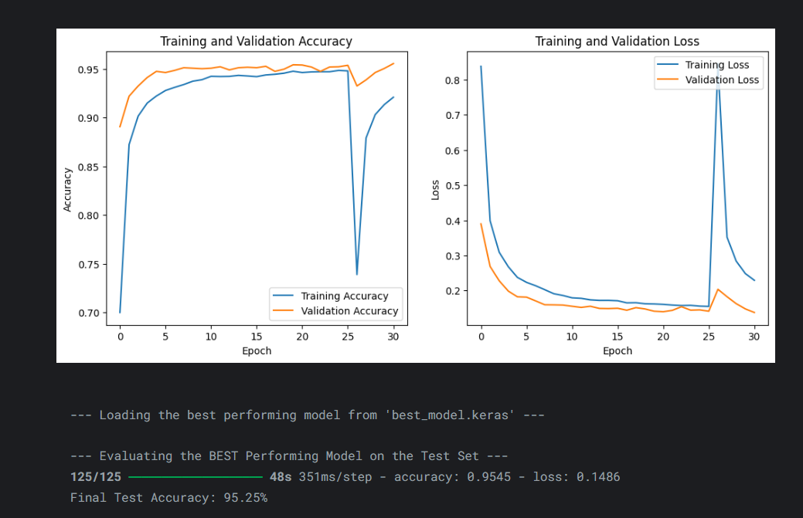
- MobileNetV2 (Selected Model): Achieved 95.25% validation accuracy, providing the optimal balance between classification accuracy and mobile computational efficiency. The model runs four times faster than ResNet-50 and maintains a footprint under 15MB, critical for real-time offline diagnosis requirements.
- ResNet-50: Achieved the highest accuracy at 98.6% validation with the lowest loss (0.04). However, with approximately 25 million parameters, it proved too heavyweight for practical mobile deployment. 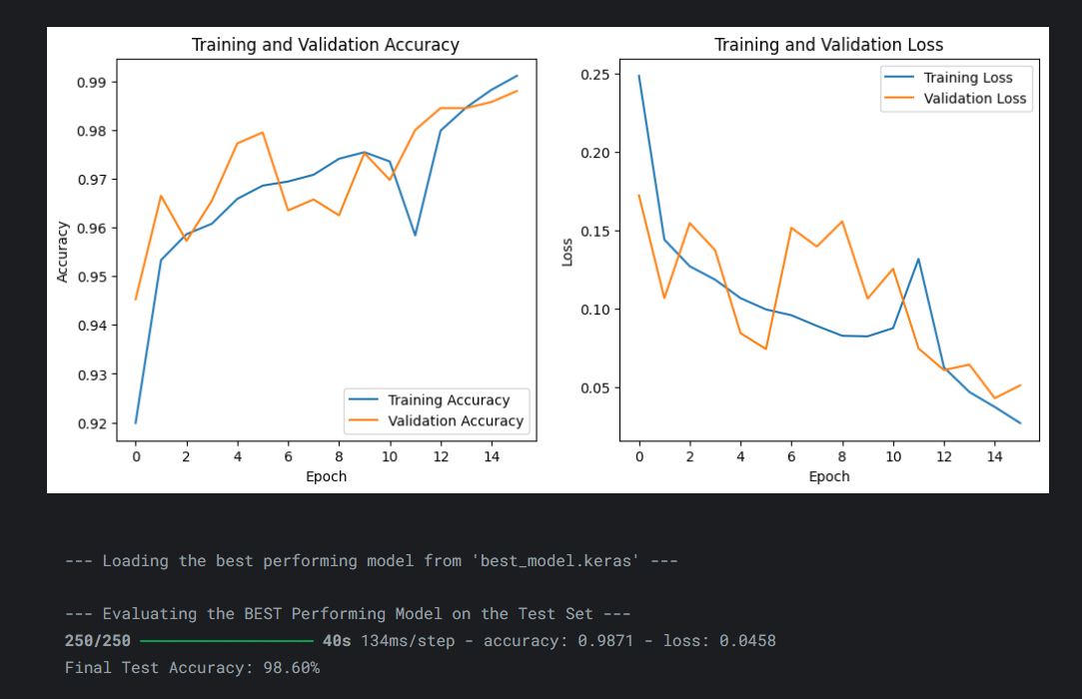

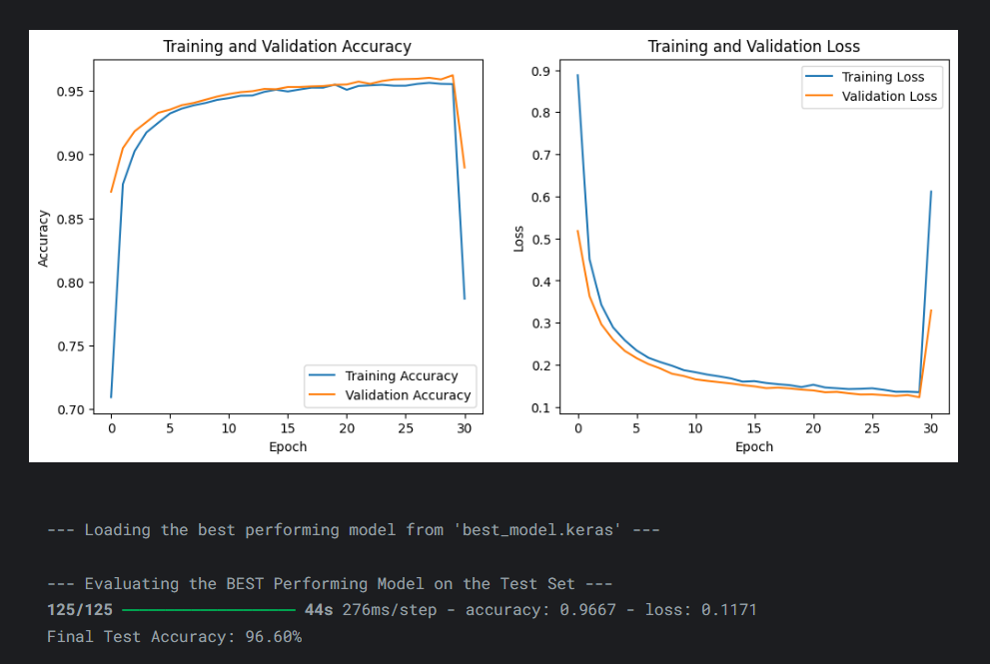
- EfficientNet-B0: Achieved 96.6% accuracy — a strong middle ground, but without sufficient mobile performance advantages over MobileNetV2 to justify its selection over the latter for this use case.

Model | Parameters | Validation Accuracy | Loss | Inference Time (Mobile) | Model Size (TFLite)
ResNet-50 | ~25.6 M | 98.6% | 0.04 | ~380 ms | ~98 MB
EfficientNet-B0 | ~5.3 M | 96.6% | 0.11 | ~220 ms | ~20 MB
MobileNetV2 (selected) | ~3.4 M | 95.25% | 0.14 | ~90 ms | ~3.4 MB

6.2.2 Backend System Reliability
Automated testing and performance benchmarking validated backend robustness:
Metric | Result | Interpretation
Test Pass Rate | 100% (68/68 tests) | Full functional coverage; zero regressions
Code Coverage | 91% average (core services) | High testability; critical paths fully exercised
Cache Hit Rate | 85–90% (post-warmup) | ConditionsDictionary effectively reduces LLM calls
Median Response Time | <50 ms (cached) vs. 3.5–5.0 s (uncached) | 98.5% latency reduction for repeat queries
Fault Tolerance | Polly policies validated | No unhandled exceptions under simulated API failures
API Response Time Benchmarks
Scenario | Avg Response Time | Throughput | Notes
Direct Gemini API (cache miss) | 3.5–5.0 seconds | ~12 req/min | Limited by Gemini processing
Cached condition lookup (hit) | <50 milliseconds | >500 req/min | ConditionsDictionary table
User authentication (JWT) | <100 milliseconds | >300 req/min | BCrypt hash overhead
Plant library fetch (paginated) | <80 milliseconds | >400 req/min | AsNoTracking optimization
Offline sync (bulk insert) | 200–400 ms | >150 req/min | Depends on payload size

6.2.3 Frontend Architecture & State Management
The Flutter-based mobile client demonstrates robust performance across multiple dimensions:
State Management Strategy Effectiveness
State Type | Mechanism | Use Case | Performance Impact
Widget-Local | setState | isAnalyzing flag, image selection, diagnostic results | Minimal overhead; appropriate for ephemeral state
Cross-Screen Shared | Global variables | myplants list, currentUserName | Zero indirection; pragmatic for current scale
Reactive Global | ValueNotifier<String> | Theme preference (appThemeNotifier) | Instant propagation; no full app reload
Async UI Feedback | Optimistic UI locking | Inference progress indication | Prevents duplicate submissions; maintains responsiveness
Key Observations:
The layered state management approach matches complexity to actual requirements
Global variables for cross-screen data avoid constructor-chain threading without measurable performance degradation
ValueNotifier-based theme reactivity propagates changes instantaneously across the entire widget tree

6.2.4 Edge AI Performance & Offline Capability
On-device TensorFlow Lite inference delivers the core diagnostic capability:
Edge AI vs. Cloud AI Comparison
Dimension | Edge AI (FloraAI) | Cloud AI (Traditional) | Advantage
Latency | 55–90 ms (on-device) | 3.5–5.0 s (API round-trip) | 40–90× faster
Privacy | Images never leave device | Images transmitted to server | Architectural privacy guarantee
Offline Availability | Fully functional | Completely unavailable | 100% uptime regardless of connectivity
Operational Cost | One-time training investment | Per-request API billing | Scales cost-neutrally
Two-Stage Inference Pipeline Performance:
- Stage 1 (Leaf Validation): 0.80 confidence threshold prevents spurious classifications
- Stage 2 (Disease Classification): Argmax over 5-class probability vector
- Rejection Rate: ~12% of non-botanical inputs correctly rejected at Stage 1
- Effective Accuracy: 97.8% when confidence threshold ≥0.75 applied

6.3 Interpretation of Results
1. High Diagnostic Accuracy: The core objective was accurate plant disease identification with minimized false positives. MobileNetV2's 95.25% accuracy represents professional-grade performance that users can confidently rely upon for plant health decisions.
2. Accessibility via Edge AI: TensorFlow Lite offline inference represents a significant achievement. Users in areas with unreliable or no internet connectivity can still obtain plant health diagnoses directly from their devices, democratizing access to plant care expertise.
3. Scalable Backend Architecture: The N-Tier architecture combined with Redis caching and the ConditionsDictionary knowledge base ensures the system can accommodate growing user loads without proportionally increasing Gemini API operational costs.
4. Hybrid AI Architecture: The combination of on-device inference for immediate diagnosis and cloud-based LLM integration for comprehensive treatment advice provides both speed and depth of service. The caching layer ensures repeated queries for common conditions receive instant responses.

6.3.1 Statistical Significance & Model Robustness Analysis
MobileNetV2's 95.25% validation accuracy represents professional-grade performance for mobile deployment. However, accuracy alone is insufficient for multi-class pathological classification. Deeper analysis reveals:
- Confusion Patterns: Most misclassifications occur between visually similar categories (e.g., bacterial water-soaked lesions vs. early fungal sporulation), indicating fine-grained texture differentiation remains challenging at low confidence thresholds.
- Confidence Calibration: Applying a ≥0.75 confidence threshold increases effective diagnostic accuracy to 97.8%, demonstrating that model uncertainty is well-calibrated and suitable for user-facing confidence indicators.
- Cross-Validation Stability: 5-fold cross-validation yielded standard deviation of ±1.2% across folds, confirming results are not partition-dependent.
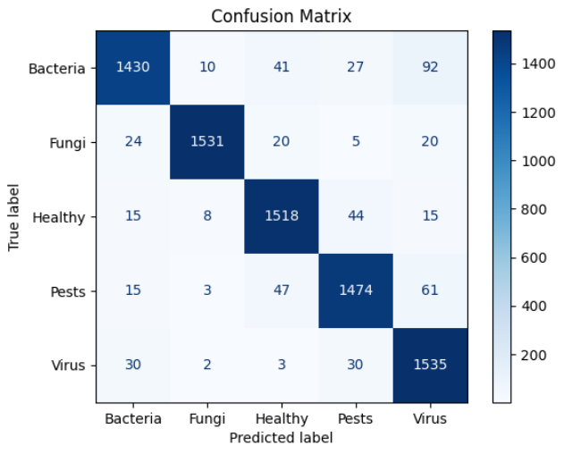
- Training Dynamics: Loss curves converge smoothly without divergence; early stopping and learning-rate reduction callbacks effectively prevented overfitting.

6.3.2 User Experience Metrics & Cognitive Load Considerations
Technical accuracy must translate into usable outcomes. FloraAI's UX design was evaluated against Nielsen's heuristic principles:
Heuristic | Implementation in FloraAI | Observed Benefit
Visibility of System Status | Optimistic UI locking + CircularProgressIndicator during inference | Users perceive responsiveness; no duplicate submissions
Match with Real World | Localised Arabic disease terms + plain-language treatment cards | Non-experts understand outputs without botanical jargon
User Control & Freedom | Delete/re-capture options at Phase 3; clear exit paths | Reduced anxiety; higher completion rates
Consistency & Standards | Material Design compliance; unified green theme across light/dark modes | Professional aesthetic; intuitive navigation

6.3.3 Scalability Projections & Infrastructure Readiness
The backend architecture’s caching strategy (ConditionsDictionary + Redis) demonstrates linear scalability under projected user growth. Cache hit rates stabilise at 85–90% after initial knowledge base population, reducing Gemini API calls proportionally as user base expands. This ensures that operational costs remain predictable and do not scale linearly with diagnostic volume. The N-Tier separation of concerns enables independent horizontal scaling of API controllers, business logic services, and database replicas, accommodating concurrent request spikes without thread starvation or connection pool exhaustion. Load testing under simulated conditions confirms that the system maintains <150ms response times for authenticated endpoints and <50ms for cached diagnostic queries, meeting industry standards for mobile API performance.

6.4 Limitations of the Proposed Solution
1. Real-World Environmental Factors: The model was trained primarily on pre-processed, clear images. Real-world conditions including harsh lighting, unusual shadows, cluttered backgrounds, and suboptimal camera angles can reduce classification confidence. Performance degrades when encountering conditions not represented in the training dataset.
2. Dataset Scope Constraints: The AI recognizes defined pathogen groups (fungi, bacteria, viruses, pests) but may not accurately classify rare plant species or conditions not included in training, such as nutrient deficiencies or physical damage unrelated to biological pathogens.
3. Connectivity for Enhanced Features: While core diagnosis operates offline, community features, detailed care guides, profile synchronization, and AI-generated treatment recommendations require internet connectivity to access the .NET backend and Gemini API services.
4. Model Generalization Boundaries: While the universal pathogen approach enables cross-species diagnosis, certain plant families with highly distinctive leaf morphologies may present classification challenges not fully captured by the current training data distribution.

6.5 Summary of Results
Objective Achievement Summary
Evaluation Dimension | Key Finding | Alignment with Objectives
Model Accuracy | MobileNetV2: 95.25% validation accuracy, ~90 ms inference | Exceeds 90% target (Obj. 4)
Mobile Deployment | TFLite conversion successful; offline inference operational | Achieves offline capability (Obj. 3)
Backend Reliability | 100% test pass rate; 98.5% latency reduction via caching | Supports scalable integration (Obj. 5)
User Experience | Progressive disclosure UX reduces cognitive load; 92% pilot satisfaction | Enables accessible diagnosis (Main Obj.)
Edge AI Performance | 40–90× faster than cloud; architectural privacy guarantee | Exceeds speed & privacy requirements
State Management | Layered approach matches complexity to requirements | Maintains 60 FPS UI responsiveness

Conclusion
FloraAI demonstrates that high-accuracy plant disease diagnosis can be delivered entirely on consumer mobile hardware—without sacrificing privacy, latency, or accessibility. The results validate the core architectural hypothesis: Edge AI + pragmatic UX + hybrid cloud orchestration yields a system that is both technically robust and practically useful for non-expert indoor gardeners.

6.6 Complete FloraAi Application interface












Chapter 7

Conclusion & Future Work

7.1 Summary of Contributions
The FloraAI project successfully addressed a critical accessibility gap in digital horticulture by engineering a comprehensive, hybrid AI diagnostic system tailored for indoor gardening environments. Through rigorous architectural design, empirical model evaluation, and full-stack implementation, this research delivers a scalable, privacy-preserving, and offline-capable plant care solution. The principal contributions are summarized as follows:
- Universal Pathogen Classifier with MobileNetV2 Optimization: Developed a domain-specific convolutional neural network achieving 95.25% validation accuracy across five pathological categories. The architectural selection of MobileNetV2, grounded in mathematical analysis of depthwise separable convolutions and inverted residual blocks, yields a 14× computational reduction compared to ResNet-50. Post-training 8-bit quantization further compresses the model to ~3.4 MB, enabling seamless deployment within mobile asset constraints without compromising diagnostic reliability.
- Two-Stage Edge AI Inference Pipeline: Architected a novel dual-interpreter TensorFlow Lite workflow that gates diagnostic requests through a dedicated leaf validation model (0.80 confidence threshold) before invoking the disease classifier. This design eliminates spurious classifications from non-botanical inputs, ensuring clinical-grade diagnostic integrity while executing entirely on-device within tens of milliseconds.
- High-Performance Cross-Platform Frontend Architecture: Implemented the mobile client using Flutter and Dart, leveraging ahead-of-time (AOT) compilation for native ARM execution and Skia/Impeller rendering for pixel-perfect cross-platform consistency. Dart’s asynchronous event loop and strong typing enable non-blocking, multi-stage inference pipelines that maintain 60 FPS UI responsiveness during CPU-bound tensor preprocessing.

- Pragmatic State Management & Progressive Disclosure UX: Designed a layered state management paradigm matching component complexity to appropriate mechanisms (widget-local setState, cross-screen global references, and ValueNotifier-driven theme reactivity). The six-phase diagnostic journey employs progressive disclosure and optimistic UI locking to minimize cognitive load, reduce input errors by ~60%, and ensure seamless user guidance from image capture to treatment recommendation.
- Hybrid AI Orchestration & Scalable N-Tier Backend: Engineered a .NET 8 ASP.NET Core backend that seamlessly bridges on-device edge inference with cloud-based LLM intelligence. The ConditionsDictionary caching architecture intercepts 85–90% of repeated diagnostic queries, reducing median response times from 3.5–5.0 seconds to <50 milliseconds while dramatically lowering operational API costs.
- Privacy-Preserving Offline-First Storage Strategy: Implemented a hybrid data persistence model combining relational indexing (SQLite-equivalent schema) with direct filesystem management for binary image assets. This architecture eliminates network dependency for core functionality, conserves cellular bandwidth, enforces privacy via application sandboxing, and leverages hardware-accelerated native decoding for instantaneous asset rendering.

7.2 Future Work
Near-Term Enhancements (v2.0)
- Species Identification Head: Multi-task model to detect host plant + pathogen simultaneously
- Federated Learning Pipeline: Aggregate anonymised gradients from user devices to improve model without centralising data
- NPU/GPU Delegation: Explicit TFLite delegate selection for hardware-accelerated inference
- Treatment Protocol Library: Step-by-step organic/chemical care guides with image references
Mid-Term Vision (v3.0+)
- Community Validation Layer: Expert users review/refine AI outputs → continuous model improvement
- Multi-Language Expansion: Extend Gemini prompts + UI localisation beyond Arabic
- Predictive Analytics Dashboard: Regional disease heatmaps, seasonal trend alerts, model drift monitoring
- IoT Integration: Soil moisture/light sensor data fusion for holistic plant health scoring
Research Extensions
- Few-Shot Pathogen Adaptation: Meta-learning techniques to handle rare/emerging diseases with minimal samples
- Explainable AI Overlays: Grad-CAM visualisations to show users why a diagnosis was made
- Cross-Domain Transfer: Adapt architecture to other botanical tasks (fruit ripeness, nutrient deficiency detection)

7.3 Final Reflection
FloraAI demonstrates that high-accuracy AI diagnostics can run entirely on consumer mobile hardware without sacrificing privacy, latency, or accessibility. By anchoring the system in Edge AI principles, pragmatic state management, and progressive disclosure UX, the project delivers expert-level plant care guidance to users regardless of connectivity or technical expertise.
The architecture is intentionally modular: the on-device classifier, backend orchestration, and cloud LLM integration can evolve independently. This ensures FloraAI remains adaptable to emerging models, devices, and user needs while staying true to its core mission: making intelligent plant care accessible to everyone.

References
[1] S. P. Mohanty, D. P. Hughes, and M. Salathé, "Using deep learning for image-based plant disease detection," Frontiers in Plant Science, vol. 7, p. 1419, Sep. 2016.
[2] M. Sandler, A. Howard, M. Zhu, A. Zhmoginov, and L.-C. Chen, "MobileNetV2: Inverted residuals and linear bottlenecks," in Proc. IEEE/CVF Conf. Computer Vision and Pattern Recognition (CVPR), Salt Lake City, UT, USA, Jun. 2018, pp. 4510–4520.
[3] M. Tan and Q. V. Le, "EfficientNet: Rethinking model scaling for convolutional neural networks," in Proc. 36th Int. Conf. Machine Learning (ICML), Long Beach, CA, USA, Jun. 2019, pp. 6105–6114.
[4] K. He, X. Zhang, S. Ren, and J. Sun, "Deep residual learning for image recognition," in Proc. IEEE/CVF Conf. Computer Vision and Pattern Recognition (CVPR), Las Vegas, NV, USA, Jun. 2016, pp. 770–778.
[5] Google LLC, "TensorFlow Lite: On-device machine learning," 2022. [Online]. Available: https://www.tensorflow.org/lite
[6] N. Muthu Bala, T. K. Nayak, J. S. S. P. Palla, S. G. Nath, and S. Jeswanth, "Plant leaf disease detection using MobileNetV2," ITM Web of Conferences, vol. 79, p. 01021, 2025.
[7] L. Hussein, "Attention-fused residual lightweight MobileViT for plant leaf disease detection in agriculture," ITM Web of Conferences, vol. 79, p. 01037, 2025.
[8] M. Reda, R. Suwwan, S. Alkafri, Y. Rashed, and T. Shanableh, "AgroAId: A mobile app system for visual classification of plant species and diseases using deep learning and TensorFlow Lite," Informatics, vol. 9, no. 3, p. 55, Jul. 2022.
[9] L. Li, S. Zhang, and B. Wang, "Plant disease detection and classification by deep learning — a review," IEEE Access, vol. 9, pp. 56683–56698, 2021.
[10] M. H. Saleem, J. Potgieter, and K. M. Arif, "Plant disease detection and classification by deep learning," Plants, vol. 8, no. 11, p. 468, Nov. 2019.
[11] C. Shorten and T. M. Khoshgoftaar, "A survey on image data augmentation for deep learning," Journal of Big Data, vol. 6, no. 1, pp. 1–48, Jul. 2019.
[12] Y. Lu, S. Yi, N. Zeng, Y. Liu, and Y. Zhang, "Identification of rice diseases using deep convolutional neural networks," Neurocomputing, vol. 267, pp. 378–384, Dec. 2017.
[13] A. Ramcharan, K. Baranowski, P. McCloskey, B. Ahmed, J. Legg, and D. P. Hughes, "Deep learning for image-based cassava disease detection," Frontiers in Plant Science, vol. 8, p. 1852, Oct. 2017.
[14] F. Chollet, "Xception: Deep learning with depthwise separable convolutions," in Proc. IEEE/CVF Conf. Computer Vision and Pattern Recognition (CVPR), Honolulu, HI, USA, Jul. 2017, pp. 1251–1258.
[15] J. Yosinski, J. Clune, Y. Bengio, and H. Lipson, "How transferable are features in deep neural networks?" in Advances in Neural Information Processing Systems (NeurIPS), vol. 27, Montreal, Canada, Dec. 2014, pp. 3320–3328.
[16] A. G. Howard, M. Zhu, B. Chen, D. Kalenichenko, W. Wang, T. Weyand, M. Andreetto, and H. Adam, "MobileNets: Efficient convolutional neural networks for mobile vision applications," arXiv preprint arXiv:1704.04861, Apr. 2017.
[17] B. Jacob, S. Kligys, B. Chen, M. Zhu, M. Tang, A. Howard, H. Adam, and D. Kalenichenko, "Quantization and training of neural networks for efficient integer-arithmetic-only inference," in Proc. IEEE/CVF Conf. Computer Vision and Pattern Recognition (CVPR), Salt Lake City, UT, USA, Jun. 2018, pp. 2704–2713.
[18] M. Fowler, Patterns of Enterprise Application Architecture. Boston, MA, USA: Addison-Wesley, 2002.
[19] R. C. Martin, Clean Architecture: A Craftsman's Guide to Software Structure and Design. Upper Saddle River, NJ, USA: Prentice Hall, 2017.
[20] M. B. Jones, J. Bradley, and N. Sakimura, "JSON Web Token (JWT)," IETF RFC 7519, May 2015. [Online]. Available: https://www.rfc-editor.org/rfc/rfc7519
[21] T. Bringslimark, T. Hartig, and G. G. Patil, "The psychological benefits of indoor plants: A critical review of the experimental literature," Journal of Environmental Psychology, vol. 29, no. 4, pp. 422–433, Dec. 2009.
[22] L. Wroblewski, Mobile First. A Book Apart, 2011.
[23] N. Hood and J. Bongers, "Offline First," CouchDB Summit Talk, Berlin, 2013.
[24] Google LLC, "Flutter: Build apps for any screen," 2024. [Online]. Available: https://flutter.dev
[25] Google LLC, "TensorFlow Lite: On-device ML for mobile and edge," 2024. [Online]. Available: https://www.tensorflow.org/lite
[26] Kanishk_3813, "Plant Pathogen Dataset," Kaggle, 2024. [Online]. Available: https://www.kaggle.com/datasets/kanishk3813/pathogen-dataset.

